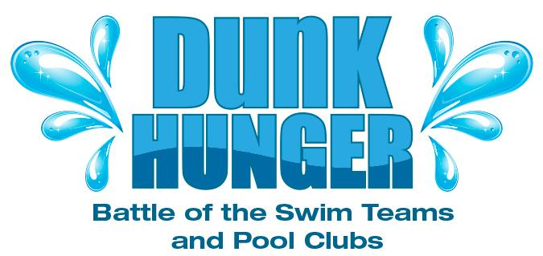

Greetings Avalon Swim Team Families,

Avalon Swim Team registered to participate for the first time in the 4th annual Dunk Hunger Food Drive, benefiting FeedMore’s Central VA Food Bank!
Battle of the Swim Teams & Pool Clubs is a food drive among area pool clubs and swim teams and has donated the equivalent of 71,000 meals in the past three years. Summer is a critical time for FeedMore and Avalon can work together to help stock the Food Bank. We encourage everyone to bring food every time you visit the pool (put in plastic bin) or donate funds online at www.feedmore.org/dunkhunger. As swim teams compete for honors in the freestyle or crawl, they can also take part in a fun new race to generate hunger relief. The swim team or pool club that collects the largest overall donation by July 31, will enjoy a free end of summer pool party bash in August and bragging rights as the 2015 Dunk Hunger Gold Medal Winners! Last year’s winner was Canterbury Recreation Association – will they claim the gold medal for the third year in a row, or will they be dethroned??

Remember: Every $1.00 donated = 5 pounds of food and you receive a tax deduction!

If you are interested in helping out please contact Jennifer Cooper jfoutz2000@yahoo.com.

A huge thank you to our sponsors to date:
· Gold Medal – Walgreens and Virginia Family Dentistry
· Silver Medal – College Nannies + Tutors, FocusMD, NOVA Swim, and Ortho VA/Ortho After Hours
· Bronze Medal – Westchester Commons

Dates: Now through July 31
Where: Avalon Swim Club
What: Food Drive to benefit FeedMore’s Central VA Food Bank
Food: Canned Meats & Fish, Canned Fruits & Vegetables, Peanut Butter, Hot & Cold Cereals, Pasta & Rice
Funds: $1 = 5 pounds Donate online at www.feedmore.org/dunkhunger
Contact: Jennifer Cooper jfoutz2000@yahoo.com

