
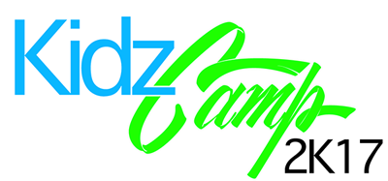


When: June 12th to 16th from 12P.M. to 4P.M.

Where: Alexis’s & Riley’s houses in Woodfield & Northcliff

Who: Hosted by Alexis Martin and Riley Busbee for kids ages 5-11

What: A week full of swimming, games, and activities for kids

How Much: $110 per child

If your child is planning to come, or if you have any questions, please email or call/text us beforehand so we can provide you with the information for the week.
Alexis- martin.alexis44@gmail.com 770-403-7903
Riley- Rileybusbee@gmail.com 404-414-1789

We hope your child can join us!

