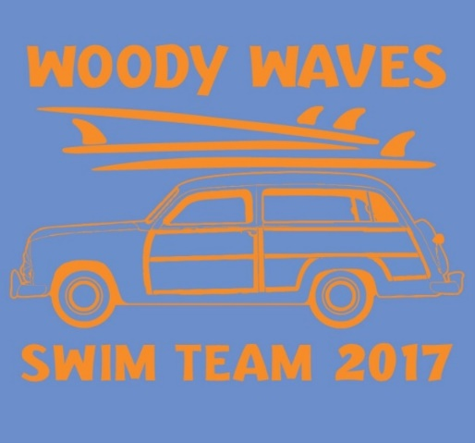
Private
Swim Lessons

Does your child need some extra attention to improve his or her technique? Our coaches are available for swim lessons outside of our normal practice time. Feel free to contact them with questions or concerns using the information below or you may talk with them after practice. Our coaches are also available to do lessons with kids who are not on the swim team.

Head Coach | Individual lesson  $20 for 30 min
Grayson Blount | 678-764-2266
Assistant Coaches | Individual Lesson  $15 for 30 min
Riley Busbee | 404-414-1789
Alexis Martin | 770-403-7903
Jake Markland | 770-876-4313
Grant Sauer | 678-234-9937

