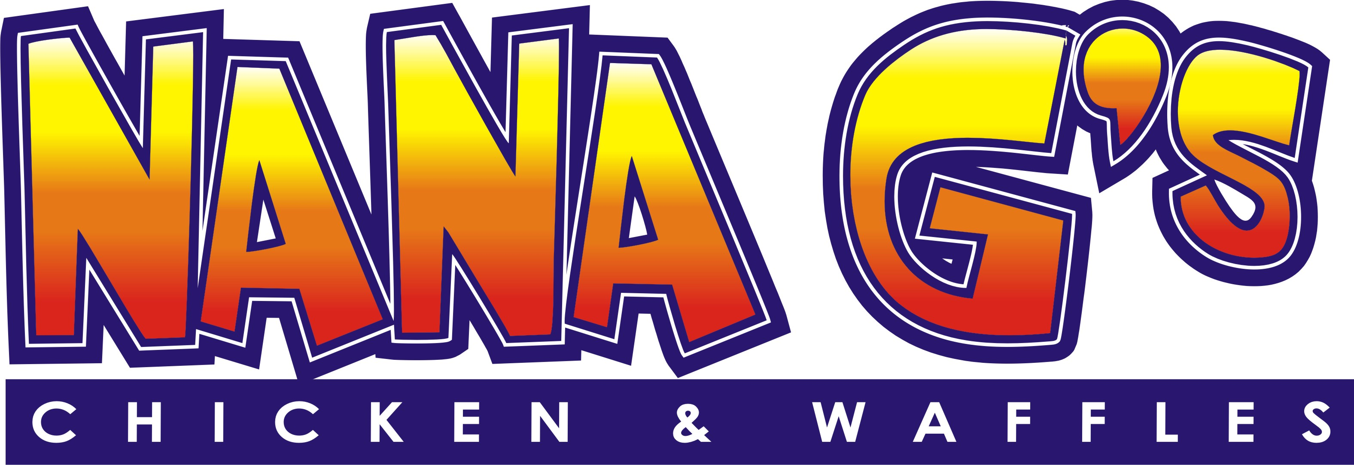

#1 – Nana G’s - $5.00
Bacon Infused Belgian waffle – topped with warm maple syrup
and sprinkled with powdered sugar.

#2 – Papa G’s - $9.00
Bacon Infused Belgian waffle – and lightly seasoned chicken
strips, topped with warm maple syrup and sprinkled with
powdered sugar.

#3 – Auntie P’s - $6.00
Bacon Infused Belgian waffle – topped w/fresh fruit of the day,
warm maple syrup and sprinkled with powdered sugar.

#5 – Heavy’s Chicken Boxes – 8.00
3-Pc. Seasoned chicken strips with freshly cut seasoned fries,
served w/honey mustard sauce.

#9 - Uncle Willie’s - $7.00
A fried chicken soft taco with bacon, lettuce, cheese, topped
with an aloi sauce, and freshly seasoned fries.

#8 - Stella’s Salad - $6.00
Romaine Lettuce, w/sliced seasoned chicken strips, cheddar
cheese, chopped bacon and honey mustard dressing.

#6 - Aunt Jeans Wings – wings with fresh cut fries $10.00

Drinks – additional fee $1.00 ea.
Cokes, Watermelon Soda, Sprite, Water
Flavored Lemonade-3.00

