2016 MSSL Championship Meet: T-Shirt Order Form

There will only be one screening of the 2016 shirts. In 2016 we are pre-ordering shirts @ $10 each or $15 IF NOT PREORDERED. The league will order a few extra shirts to sell @ $15. The 2016 year’s shirt front design and 2015 back are shown below.

FRONT BACK
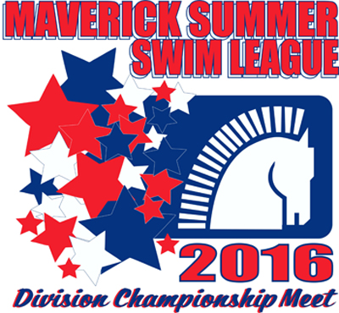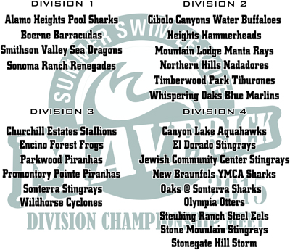

Name _____________________________ Email_______________________
Phone #___________________________ Team Name* ________________________
(*Be sure to give the team name of your subdivision and not your mascot.)

White short-sleeve (Heavy, Pre-shrunk Cotton) shirt: $10.00 pre-order or $15 if not preordered.
______QTY. Youth Small _______ QTY. Adult Small
______QTY. Youth Medium _______ QTY. Adult Medium
______QTY. Youth Large _______ QTY. Adult Large
______QTY. Youth X-Large _______ QTY. Adult X-Large
_______ QTY. Adult XX-Large
_______ QTY. Adult 3X-Large
TOTAL $ ___________

MAKE CHECKS PAYABLE TO: YOUR TEAM for preordered shirts
TEAM VOLUNTEER COLLECTS CHECKS/MONEY & T-SHIRT ORDER FORM.
ORDERS MUST BE PRE-PAID AND DUE BY: FRIDAY, JUNE 17 @ 11 AM

