Silver Linings Spring Gift Show
Neely Farm Clubhouse

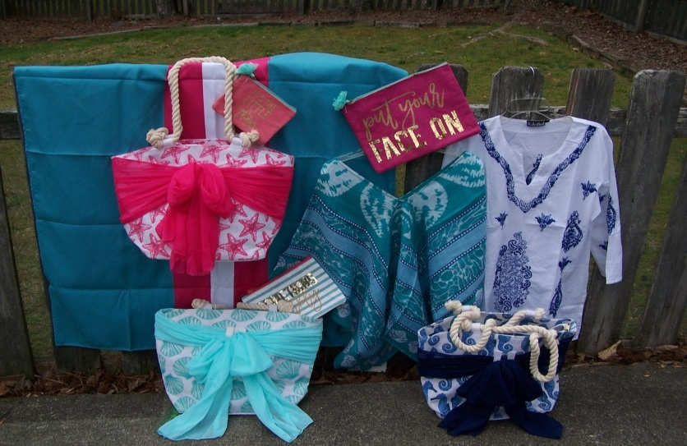
Come Shop for Your….
Cool, Unique, and Personalized
Mother's Day gifts
Graduation gifts
Teacher and Hostess gifts
AS ALWAYS, Gift Wrapping is FREE

Monday, April 24th 9am-8pm
Tuesday, April 25th 9am-8pm (wine & cheese event 6-8)
Wednesday, April 26th 9am-8pm
Thursday, April 27th 9am-3pm

Bring Your Friends & Shop Early for best selection!
Raffle Ticket
Please enter the raffle limited to Neely Farm swim team friends and family!

Name ____________________________
Phone ____________________________
Email _____________________________

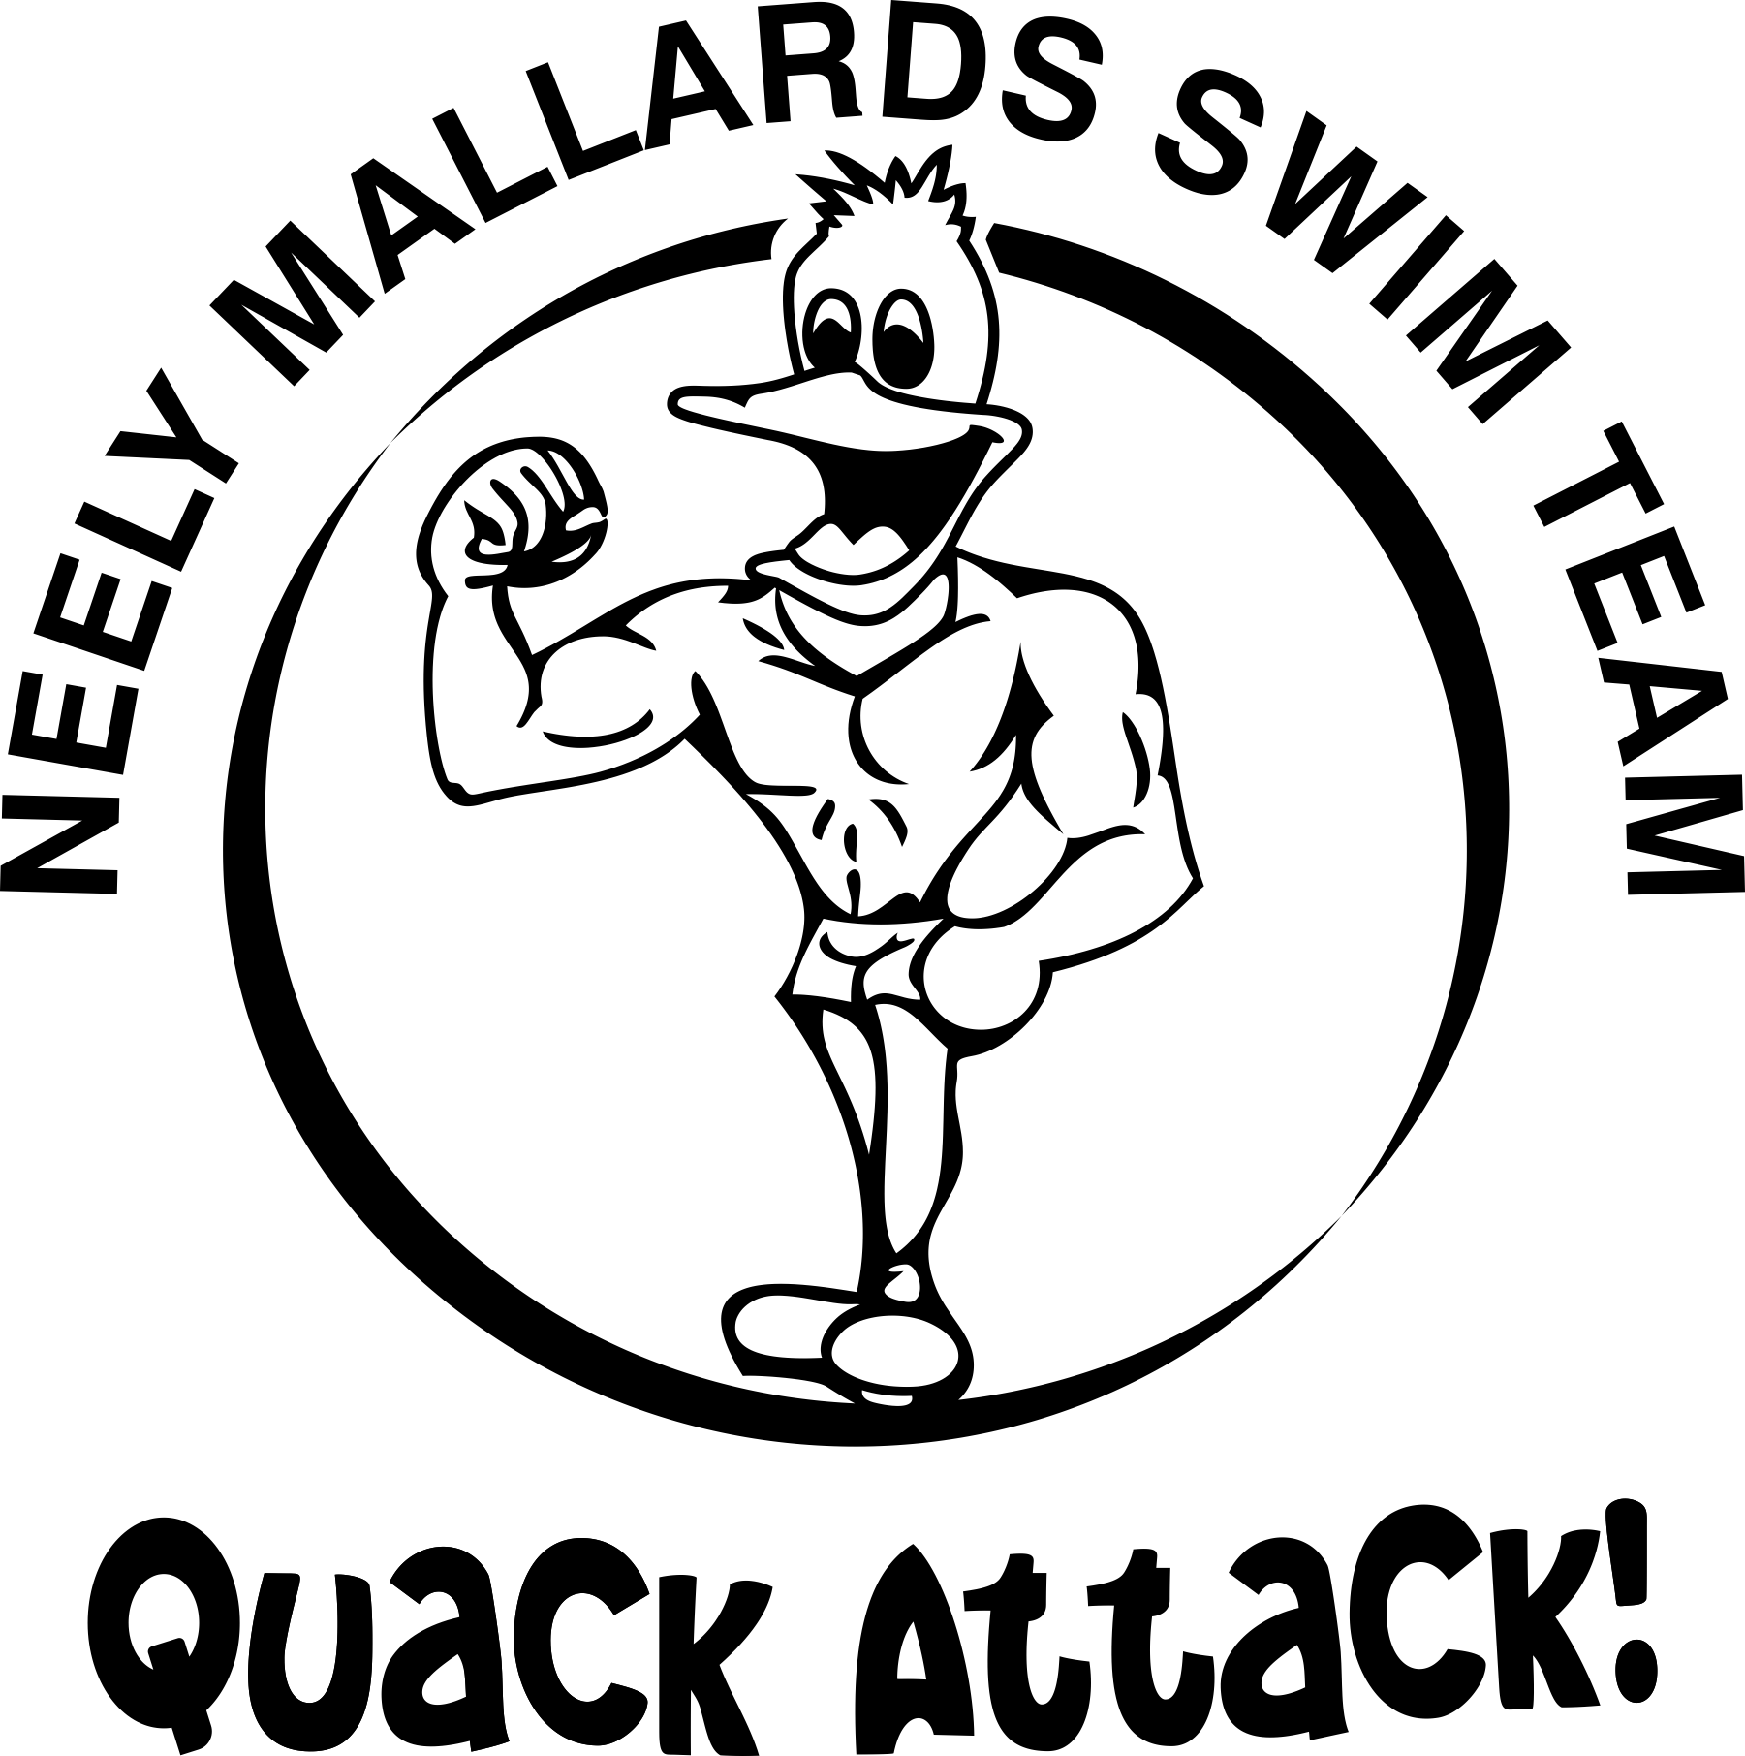

Our Neely Mallards Swim Team gets 10% of our sales for the entire event! Please come support the swim team and automatically be entered into the raffle drawing.
