TEAM DINNER
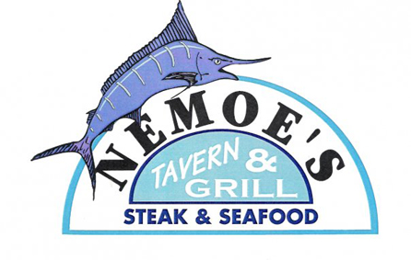
THIS IS A GREAT TIME TO GATHER WITH FRIENDS, FAMILY AND SUPPORT OUR SPONSORS THAT HELP THE TEAM GROW.
PLEASE JOIN US WEDNESDAY NIGHT ON JUNE 3rd
NEMOE’S FOR DINNER STARTING AROUND 5:30PM
NEMOE’ HAS BEEN SPONSORING US FOR 3 YEARS NOW AND FRED THE OWNER IS ALWAYS WILLING TO HELP THE TEAM. LET’S SHOW OUR SUPPORT BY RECIPROCATING AT NEMOE’S. BESIDES THE FOOD IS FANTASTIC AT A REASONABLE PRICE.

