What to bring (LABEL EVERYTHING!):
**Starting in 2014, heat sheets will be emailed to families the day before each dual meet. A very limited number MAY be for sale or a copy of the heat sheet will be posted at dual meets. Please print and bring your heat sheet to the meet.

Swimmers bring:
• Green swim cap, green suit, team t-shirt
• 2 pairs of Goggles (properly adjusted and previously worn swimming)
• Two or more towels (and a blanket to sit on if desired)
• Sunscreen, sunscreen (stick form) for face, sunglasses, hat (bug spray?)
• Books, cards, etc.... for entertainment between events
• Drinks: water, juice, Gatorade, Powerade
• Snacks (fruit, fiber bars, oranges, healthy snacks)

Parents bring:
• Highlighter & Permanent marker (Sharpie)
• Printed copy of the heat sheet (will be emailed the day before the meet)
• Money (for concession items - small bills please)
• Drinks and Snacks
• Folding camp chairs or blanket
• Canopy for shade (daytime meets)
• Camera – a flash isn't allowed at the start of a race

Day of the Meet:
• Apply sunscreen to your swimmer before leaving the house. DO NOT APPLY SUNSCREEN TO THE FACE (unless it is in “stick” form).
• Highlight your events on your heat sheet (printed at home)
• Mark your swimmer with a Sharpie! (First and Last name on the back of shoulder and event list - see below)
• Be on time. Warm-ups begin well before the meet start time.
• Check in at the check in table so coaches know you are here. Coaches have to submit relay changes 30 min before for the meet starts for an away meet and 45 min before the meet starts for a home meet. If your swimmer is not checked in at this time, he/she will be removed and substituted with another swimmer for relay events.
• Sit with your team
• Swimmers report to coaches
• Team will warm-up together
• Pay attention to which event number is swimming
• Have your swimmer at the ready bench around 10 heats before they are swimming (***Look for white board for events lining up)
• Have fun and cheer on your teammates!
• Do not leave pool without checking with Coach Claudia, regardless of whether your swimmer has finished their last posted event (changes in relays may not be printed on the heat sheet)
• PLEASE throw away all trash and gather belongings before leaving
** If you are running late for a meet or your child is sick on the day of a meet, pleasetext Kelly Hunt at 210-316-9086 with your swimmer's first & last name, age group, and the situation (running late, sick, etc.) as soon as you know.
** It is very important that you let us know if you are unable to attend a meet as it may affect a relay event and cause other swimmers on the team to miss out on swimming the relay.
** All swimmers are assumed attending a meet, unless you sign the orange NOT ATTENDING paper (at registration or at practice).

The Heat Sheet
Heat sheets list all the swim events in order, along with the participants in each event, what heat they are in, what lane each swimmer will occupy, and his/her previous best time in that event (if the swimmer has competed in that event before) or it will show "NT" for "No Time." To keep track of when your swimmer is swimming, it is a good idea to go through the heat sheet and highlight each of your swimmer’s events/heats.
To help swimmers keep track of what events they are swimming in, each swimmer needs a grid/chart on their arm or leg showing the event number, the heat number, the lane number, and the stroke/distance...for every race they are going to swim. You get this information from the Heat Sheet.
Find your swimmer’s name on the heat sheet. For example, find Tyler Wiley in the Sample Heat Sheet in the photo. Notice he is swimming in Event 14 in Heat 2. The numbers 1-8 correspond to the assigned lane. Tyler is in Lane 3. Next to the Event number is the distance and stroke – 50 meter Backstroke.
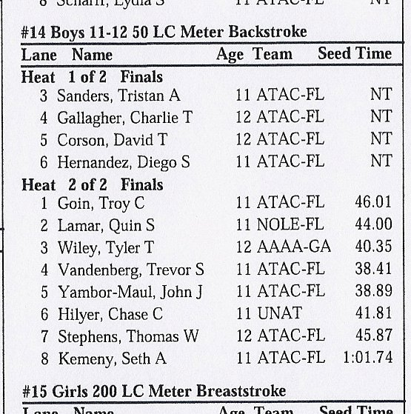
Using a waterproof marker (Sharpie), write four column headings on your swimmer’s arm
E, H, L, Stroke – for Event, Heat, Lane and Stroke respectively.
Continue filling in the grid until all of your swimmer’s event information is on the arm.
For this Event, Tyler's arm would read:
E H L Stroke
14 2 3 50 Back (means event 14 - heat 2 - lane 3 in the 50 Backstroke)

Example of what the arm or leg of your swimmer may look like:
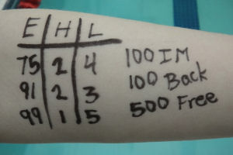

When to Line Up
Throughout meet, continually watch for what event/heat is currently begin swum in the water. Look for a large flip sign posting the event number. At home meets this is usually located at far right corner near starting blocks and starter.
Roughly 15 heats before your swimmer's scheduled heat/event, begin preparing your swimmer. Get them in or near the designated the swimmer seating area, gather his or her goggles and cap, and begin watching for the white board sign and ready bench volunteer "calling" your swimmer's event on the white board. When you see your swimmer's event posted on the white board, send your swimmer over to the Mountain Lodge Ready Bench. Ready Bench and other volunteers WILL NOT search for missing swimmers. We ask that parents assume the responsibility of preparing your child for being called to the Ready Bench.

Common Terms Used Around the Pool Deck
A ‘heat sheet’ is the swim meet ‘schedule’ that identifies each event, and when and in which lane each swimmer will race. The home team sells these schedules prior to each swim meet. Parents generally bring a pen or highlighter so it’s easier to keep track of your swimmers’ events.
Event: A race or stroke over a given distance (e.g. 50 Meters Freestyle). An event usually involves kids of the same gender and age (e.g. 9-10 Girls) but it’s not unusual to see the meet officials merging events together in order to save time
Heat: A division of an event when there are too many swimmers to compete at the same time. Usually swimmers are grouped together in a heat by their seed time.
Relay: A swimming event in which 4 swimmers participate as a team. Each one swims an equal distance of the race. There are two types of relays: Medley Relay involves all strokes (order is backstroke, breaststroke, butterfly, and freestyle) and Freestyle Relay where everyone swims freestyle.
Leg: Each swimmer in a relay swims a leg of the event.
Entry: The Individual and Relay event swimmers event list for a meet.
Warm-up: A planned session prior to a meet or practice. Usually swimmers must arrive at the pool one hour before the meet starts so they can warm-up.
Blocks: The starting platforms located behind each lane. Younger swimmers may not be prepared to start off the blocks initially, so they are allowed to start off the edge of the pool instead.
DQ, or Disqualified: A swimmer performance is not counted because of a rules infraction. A disqualification is shown by an official raising one arm with open hand above their head.
Stroke Judge: Official at the side of the pool, walking the length of the pool as the swimmers race. If the Stroke Judge sees something illegal, the swimmer may be disqualified.
False Start: a swimmer gets an unfair advantage by being in motion before the starting signal is given. Officials will disqualify a swimmer who executes a false start.
Individual Medley (IM): an event where the swimmer swims each stroke in this order: butterfly, backstroke, breaststroke, and freestyle

