CHAMPS T-SHIRT ORDER FORM
ORDER FORMS AND MONEY ARE DUE BY JUNE 27TH
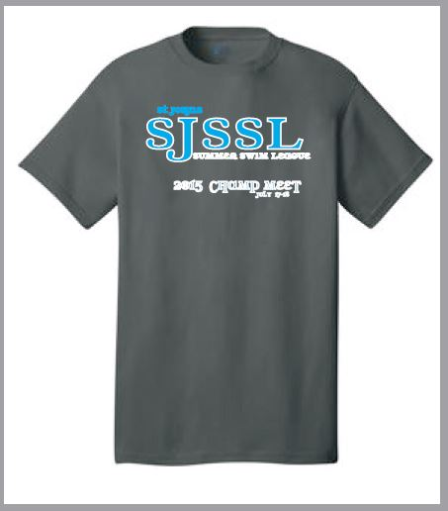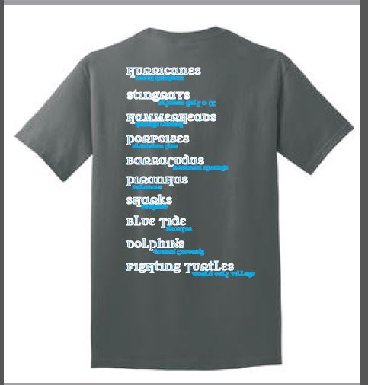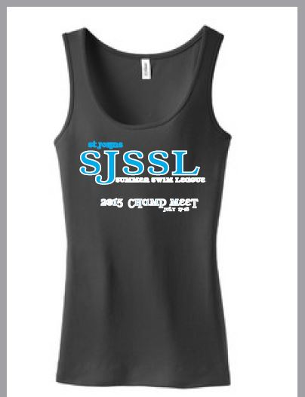
SWIMMER NAME(S) ________________________________________________________
Youth Sizes |  | Adult Sizes |  | Tank Tops
($10 per shirt) |  | ($10 per shirt) |  | ($20 per tank)
Youth S |  | S |  | S
Youth M |  | M |  | M
Youth L |  | L |  | L
 |  | XL |  | XL
 |  | ($12 per shirt)
 |  | XXL
 |  | XXXL
 | TOTAL AMOUNT DUE = |  |  | $

Please make checks payable to: “DC DOLPHINS”
Order Forms and check can be given to a DC Dolphins board member or
Mail to Attn: Terry Davis, 137 Ellsworth Cir, St Johns, FL 32259

