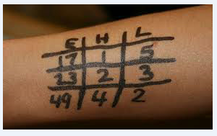

E – Event #
H – Heat #
L – Lane #

I will sometimes put the stroke out to the side as well
Fr- Freestyle
Bk- Backstroke
Br – Breaststroke
Fly – Butterfly
MR-bk = Medley Relay – backstroke
FR 3 – Free Relay – 3rd swimmer

ORDER of MEDLEY RELAY
Backstroke
Breaststroke
Butterfly
Freestyle

