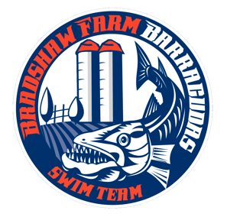

2016 Bradshaw Farm Barracudas Swim Team

Spiritwear!
- NEW! Charles River rain parka w/logo (navy or black) - $35
- NEW! Velocity running shorts (royal or black) $22
- NEW! Flannel PJ pants (youth or adult) $20
- NEW! Flannel PJ joggers (youth or adult) $25
- NEW! Flannel boxers (adult) $18
- NEW! Unstructured twill cap with logo: $20 (( navy, white or plaid ))
- NEW! Powder Puff Cuda Mom shirt: $22 (( black, royal blue ))
- NEW! Twill visors w/"Barracudas": $20(( navy or white))
- NEW! "Barracuda Mom" flair tank tops: $25 (( royal blue, navy, black ))
- NEW! Barracuda swim cap: $15
- Long sleeve “Summer of 15” tee shirt $15 (LIMITED TIME BOGO FREE)
- Barracuda magnet: $8 --- or two for $12
- Camelbak water bottle (no name added): $15
- Previous year short sleeve t-shirts: $5 (LIMITED TIME BOGO FREE)
- Previous year bag tags: $.50
- TYR bag with name and logo: $25
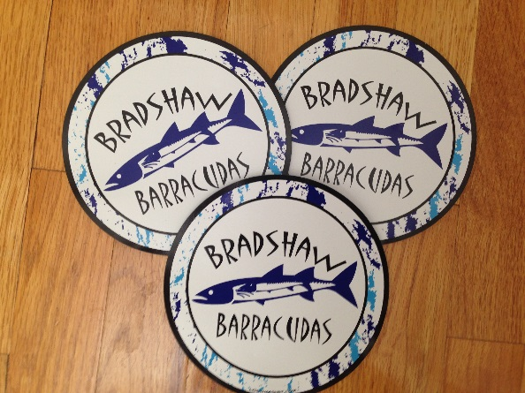

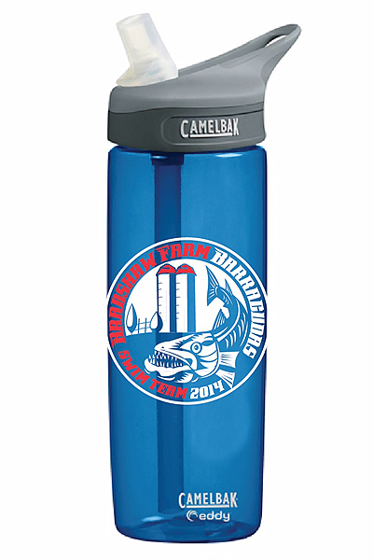 | 