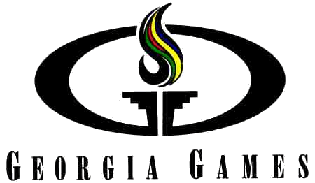
Great Warm-Up for GRPA District & State Meets!

FREE Championship T-shirts to all registered swimmers

Top 3 in each event qualify for the
National State Games of America 2017: Grand Rapids, MI

Open to ALL Youth Recreational Swimmers Statewide!

GREAT Medals & Ribbons!

Gold, Silver, and Bronze Medals for top 3 each event & Ribbons for places 4-8

Register Individually or as a Team

Submit registration online, paper, or via Hytek for 10+ more!

Partnered GRPA, CSSL & Others!!!

Olympic Day Event!

NEW Beautiful Aquatic Venue!

Plenty of Spectator Raised Seating!

NO additional Coordinator work!

NO Additional Memberships Needed!

Professional Operated!

Will be following GRPA rules & modifications where needed

Prize for top 3 coaches with most participating swimmers!!!

Earn Valuable Points towards Georgia Scholastic Sports Olympiad Competition

Sanctioned by the State of Georgia

Questions? info@georgiagames.org

June 17, 2017 CHAMPIONSHIPS
Youth Swimming
Georgia’s Grassroots Olympics

Cherokee County Aquatic Center
Register:www.georgiagames.org

Georgia Games * P.O. Box 2043 * KENNESAW, GA. 30156 *
Email Questions: staff.gabriella.milani@georgiagames.org

State Games
Program Participant
