

On behalf of our coaching staff, swim committee and YMCA, I want to welcome everyone to the start of a new swim season. We have put together this handout to assist in getting started and to anticipate some of the questions that will come up with new swimming families. In addition it allows me to outline a major structural change we are making to the workout set up. We will be moving more swimmers into the 3:30 time slot, and to make this work with the differences in ability level I will be breaking groups D and C each into sub two groups. I will have a list at the front desk to let you know where you child has initially been placed. Part of this change is to even out the numbers a little better, and part of it is to get certain groups of swimmers together for development purposes. If the assigned group presents a problem, not to worry, as I anticipate moving swimmers around throughout the year, just let me know and we’ll find a time slot that works for your needs.

I look forward to working with your children, and continuing to build a great team environment and supporting community.

Mike
PRACTICE GROUPS:
- Group A (8 & Under): Practices Monday, Wednesday and Friday at 5:45-6:30 pm
This group is designed to be a bridge from “learn-to-swim” programs to competitive swimming and to primarily prepare age 8 and under swimmers to swim 25-yard events in the four competitive strokes. Coaches will teach dives/starts and turns, technique for all four strokes and other skills required to compete in a swim meet. Although it is not required, Group A swimmers are encouraged to swim in YMCA meets. This group can also be an option for Group B swimmers with scheduling conflicts. All 8 & unders should sign up for this group.
- Group B: Practices Monday, Wednesday and Friday at 5:00-5:45 pm
This group is designed for age 9 and over swimmers who are new, or relatively new, to competitive swimming, and are still learning the “basics.” The emphases are similar to the above group with an added emphasis on preparing swimmers to compete in 50-yard events and above. Swimmers at this level will compete primarily in YMCA meets, but some may be prepared for USA Swimming meets. All new swimmers 9 & older should sign up for this group.
- Group C/C1 - Practices Monday through Friday, 5:00-6:00 pm
This group is designed for age 9-12 swimmers who are prepared to meet the demands of, and keep pace with, Group C practices. It will also include swimmers over age 12 who are not yet ready for the Group D. Coaches will work on all four strokes, starts and turns, building endurance and racing. Swimmers in this group will compete in YMCA meets, and some may compete in USA Swimming meets.
Group D/D1- Practices Monday through Friday, 3:30-5:00 pm
This group is generally for age 13 and above swimmers who are prepared for the increased demands of Group D, including both workload and intervals (as determined by the coaching staff). Coaches will continue to focus on fundamentals, but Group D is heavily focused on event-specific preparation. This group requires a strong commitment. For the training design/structure to achieve its fullest potential, swimmers’ attendance is crucial. Group D swimmers compete in YMCA meets and have the option to swim in USA Swimming meets.

Group Assignment
Group assignment is determined by Coach Mike and his assistants. Swimmers and parents are encouraged to discuss goals and progress with the coaches. All of the following (not just “measurables” like age, intervals and time standards) are taken into consideration when determining group assignment:
- The ability to make intervals/time send-offs
- Time Standards
- Age
- Ability and Potential
- Commitment and Attendance
- Practice Habits/Attitude
- Leadership
- Interaction with Others
Although these factors are primary in determining a swimmer’s “group,” coaches will work hard to make pool time available to club members. If a swimmer has a scheduling conflict and needs to swim at a different time/practice, we will try to work it out. If there is a scheduling conflict, please contact Coach Mike to discuss whether or not it is feasible and in the swimmer’s best interest.



SWIM MEET COMMONLY ASKED QUESTIONS:

How long will a meet last?
Most swim meets last about three hours, although the time may vary depending on the size of the teams, technology, and other variables.
What time should I arrive at the swim meet?
Swimmers should arrive in time to be in the pool for the allotted warm up time. The team warm up time will be announced via the team website. For away meets, directions will be available via the team website.
What should I bring to the meet?
Swimmers should remember to bring the following:
- Swim suit, preferably the team suit
- Goggles (good idea to bring a back-up pair as well)
- Swim cap (back up is recommended)
- 2 Towels (one for use during the meet and one for after the meet)
- Water bottle- Swimmers get thirsty!
- Healthy snacks
- Dry clothes to change into after the meet
- Sharpie to mark up their arms – and possibly draw some team spirit on themselves!
Parents will want to bring the following:
- Snacks – meets almost always have concession stands, and most swim teams rely on concessions for fundraising, but healthy option snacks are helpful
- Cash, preferably smaller bills – parents will need cash to purchase programs and concessions
- Pen or highlighter to mark when your swimmers event, heat, and lane, as well as to mark the swimmer’s results time
- Cushion for the bleachers
- Camera/Video Recorder
- Lots of positive energy and patience – the events should be FUN!
How does a swim meet work?
The swim meet is divided into multiple events. Each event are then divided into heats, with swimmers assigned to a lane, based on their seed times.
- An "event" at a swim meet consists of a stroke, a distance, age group, and sometimes, a gender. For instance, the 8 and under 25-yard freestyle, 9-10 50-yard freestyle, 11-12 50-yard freestyle, and 13-14 50-yard butterfly are four separate events.
  - A 25-yard race is one length of the pool, and a 50-yard race is 2 lengths, and so forth.
- Each heat is structured with the swimmers with the fastest seed times swimming last. Within each heat, the swimmer with the fastest seed time is assigned a middle lane.
All competition is age-group competition which means that children swim against others of the same age and gender. Although the heats may be mixed gender, they will be scored according to their gender. Each swimmer can participate in two point-earning events, plus a relay.
- Swimmers may participate in an event as a non point-earning individual swimmer; they will be indicated by an "X" in the meet program. This is at the coach’s discretion.
How will my swimmer know what event, heat, and lane they are swimming?
Once available, the program or schedule of events, heats, and lanes will be posted. The swimmers will mark their event, heat, and lane on their arms using a Sharpie marker. Sometimes the swim meet events, heats, and lanes are only available at the last minute. Someone on the deck will assist newer and younger swimmers with this activity.
The grid on the swimmer’s arm will look like this:
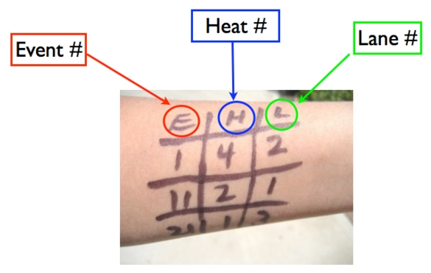
How will parents know when their child is swimming?
Programs with all events, heats, and lane assignments will be for sale prior to the start of the meet. They are typically $1 or $2. The programs are often not ready until the last minute, due to last minute changes and limited printing abilities at the local YMCA.
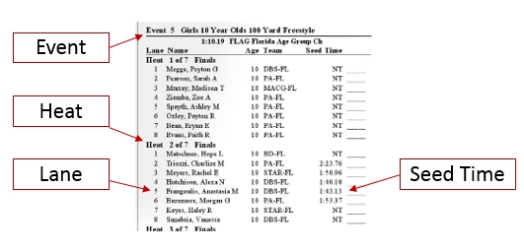
What are some of the event names?
Below are some definitions of common swim events:
Freestyle Relay: Four swimmers each swim freestyle. The distance differs by age group.
Medley Relay: Four swimmers participate, each of whom swims a different stroke. The strokes are always in this order: 1. Backstroke, 2. Breaststroke, 3. Butterfly, 4. Freestyle.
IM (individual medley): One swimmer swims all four strokes in one race. The IM order is different from the medley relay order: 1. Butterfly, 2. Backstroke, 3. Breaststroke, 4. Freestyle.
When will official results be available?
Official results will be posted to the team website, once they are available. Typically, this is within a few days of the event.
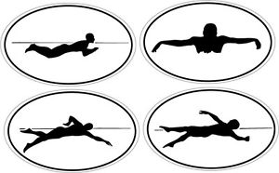
TENTATIVE MEET SCHEDULE FOR 2017/2018 SEASON
(Please keep in mind this could change so keep an eye on the website for updates!)
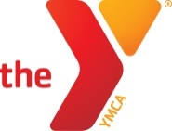
YMCA Meets:
November 18: KVY @ LRSC (Long Reach)
December 2: KVY @ NYCY (Northern York)
December 16: MMD at KVY (Mid Maine)
January 6: TCST at KVY (Twin Cities)
January 20: PBAY at KVY (Pen Bay)


USA Meets:
October 28: Haunted Hat (Husson University, Bangor)
November 11-12: MSI Developmental Meet #1 (PBAY, Camden)
December 8-10: Bowdoin Open (Bowdoin College, Brunswick)
January 27-28: MSI Developmental Meet #2 (Bates College, Lewiston)
March 15-18: MSI Junior Olympics (Bowdoin College, Brunswick)
July 19-21: MSI International Invitational (Saint John, NB Canada)


VOLUNTEER OPPORTUNITIES:
Swim meets rely on parent volunteers to run smoothly. There are a variety of roles that need to be filled:
- Timers: Each lane should have at least two timers. (No experience needed, a quick training is given before the meet begins) The meet cannot start without timers, and if there are not enough volunteers, parents will be recruited out of the stands.
- Concessions: Volunteers are needed to run the concessions stand and to donate food for sale. Proceeds from concessions help support the end of the year ceremony and other social events, as well as team equipment purchase/replacement.
- Meet Marshall and Deck Parents: These roles will help ensure that the swimmers are where they need to be for their event, heats, and lanes.
- USA/YMCA Officials: Please see Coach Mike for more information about becoming an official.
*To sign up to volunteer or to donate food items, please visit our website at: www.kvystingrays.com



CONTACT INFORMATION:
Website: www.kvystingrays.com
Facebook: www.facebook.com/KVYStingrays

Coach:
Mike Schmidt mschmidt@kvymca.org
Assistant Coaches Sara Knight & Victoria Weber

YMCA Aquatics Director:
Emily Caffry emily@kvymca.org (207) 622-9622 Ext 133

Committee Members:
Justin Bergeron justin.bergeron@hotmail.com
Kean Brown keanbr@gmail.com
Therese Cahill cahillow@gmail.com
Cheryl Gifford ccgifford33@gmail.com
Stacy Kennard sklajoie@lajoiebros.com

More Information:
Maine Swimming www.maineswimming.org
Maine YMCA Swim League www.maineymcaswimming.org


FEES:
​ 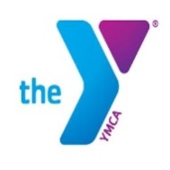
YMCA Annual Membership (required by YMCA)
Youth (1-12): $156 Annually or $13 Monthly Bank Draft
Teen (13-18): $204 Annually or $17 Monthly Bank Draft
Program Fees: Instruction, YMCA Meets, YMCA State Meet, Team Night and Caps included in program fees
- Groups A & B: $305
- Group C: $365
- Group D: $410
- For families with more than one child swimming, a $10 discount can be applied to the second swimmer.
Scholarship opportunities and payment plans are available – inquire with the front desk or Aquatics Director.
USA Fees:
- Seasonal: 38.50
- Year Round Member: $67.50
- USA Meets typically cost each swimmer between $15 to $30 per meet for entry fees
- USA Swimming is an additional forum that our swimmers compete in. We are tentatively scheduled to compete in six additional meets in USA swimming during the 2017-18 season, with four of these meets being open entries (no qualification times) and two of them (the Bowdoin Open and MSI Junior Olympics) requiring that the swimmers meet qualification standards. Unlike our Y season which runs until Y State Meet (the first weekend in March), the USA season has it’s winter championship the third weekend in March, and it’s summer championship in July. USA swimming meets provide swimmers with the opportunity to swim longer events, as well as the events they would swim during YMCA meets. It is my goal to bring every swimmer who qualifies for the Junior Olympic championship to that meet, so if your swimmer has or will qualify, then I encourage them to sign up for USA swimming. In addition, if your swimmer feels they need to swim in more meets, or wants to be part of the fun and exciting trip to Canada next summer, then I would again encourage them to sign up for USA swimming. It is voluntary, however, and no one on the team is required to swim USA meets (or join). If you have any questions about your child participating in USA swimming let Mike know.

