FINAL KVY STINGRAYS RAFFLE!
Wanna Be A Winna?
20 Prizes! = 20 Winners!
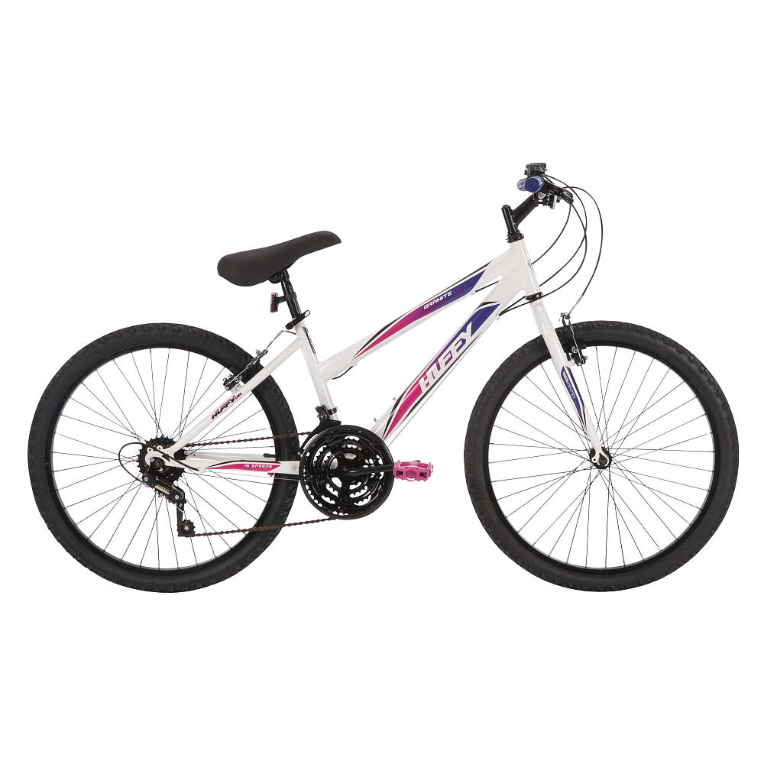
GRAND PRIZE-Win a HUFFY 24” GRANITE Mountain Bike (generously donated!)
Win 1 (or more) of 2 LIBERAL CUP Gift Certificates ($25 each)!
Win 1 (or more) of 4 Pairs of KVY Stingray Stadium Seats!
Win 1 (or more) of 6 KVY Stingray Swim Caps!
Win 1 (or more) of 7 KVY Stingray Window Decals!

