Order for 2015 City Meet Shirts and Parking Passes

As in years past, city meet shirts have to be ordered in advance, and parking passes can be for Friday and Saturday. Fill out the information below as desired, attach a check made out to Crestwood Hills Swim Team, and place in the swim team folder for Caroline Allen by 7/13.



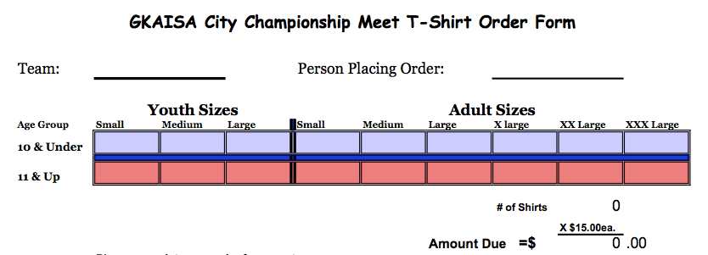

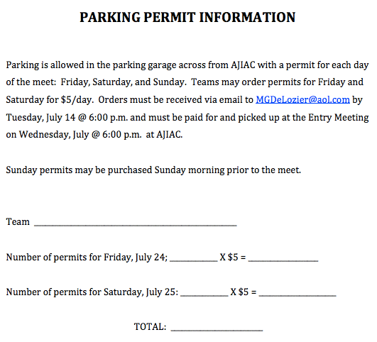

Family

