A Summer Full of Fun!
Crestwood Hills offers swimming, tennis, social events, competition, and so much more.  Crestwood Hills is a premier Swim Club, serving Knoxville for over 40 years. The pool’s main focus is family fun.  It is conveniently located between Kingston Pike and Middlebrook Pike, in the Cedar Bluff area. |   .  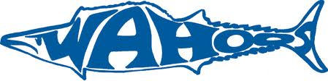

Pool Membership  - Full Family pool & tennis* memberships...............$390.00  This family plan includes all family members living  in the SAME household, including college age dependents.  - Single/Senior couple memberships...............$250.00  - Swim Team only memberships…….........$135.00  *Includes immediate family access to the pool and lighted tennis courts during normal operating hours. (There is a $5 fee required if your family would like a key for access to the tennis courts at times when the pool is closed.)  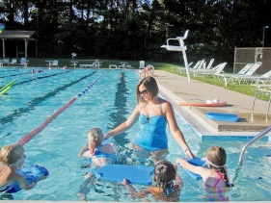   http://www.knoxnews.com/news/2011/jul/12  /educators-on-break-first-grade-teacher-gagley/ | Swim Team fees For Pool Member:  - 1st swimmer $125  - 2nd swimmer $100  - 3rd swimmer $65  - 4th or more $25 each  NEW SWIMMER DISCOUNTS:  1st swimmer $115, 2nd- $90, 3rd- $55,  4th or more $20 each  Practice Schedule:  - Age 13-18 / 8:00 – 9:45 a.m.  - Age 9-12 / 9:30 – 10:45 a.m.  - Age 8 & under – 10:30 – 11:15 a.m.  Feeder Program:  This is a special program designed for non-swimmers. Our coaching staff will work hands on with your child as they learn to swim. 10:30 – 11:15 a.m.
We are located at 8740 Fox Lonas Road between Kingston Pike and Middlebrook Pike. You will be surprised how close we are! http://cwhwahoos.swim-team.us/

