Flowers Crossing Swim Team
Alexi Owens Memorial Scholarship

Chris and Mike Owens have lived in Flowers Crossing for 25 years. One of their two children, Alexi, swam on the FCST for 6 years. During his 5th grade year, he developed a brain tumor. He was given a slim chance of survival, but was able to beat this cancer. After graduating from Brookwood in 2009, he attended both Georgia Gwinnett College and UGA. On August 17, 2013, Alexi died accidentally at college.
We have all served on the FCST board in the past, totaling over 50 years of service. As an act of support to the Owens family, we would like to honor Alexi’s memory. Alexi’s mother, Chris, was on the Flowers Crossing Swim Team board for 4 years, was the chair person for our community pools for several years, and has always been a supporting figure in our neighborhood. Thus, it is our privilege to offer a scholarship in his name to one deserving swimmer.

Thank you to FCST for assisting and good luck to all applicants!

Karen San Filippo
Pam Dietz
Connie Beumer
Laura Long
Julie Weir
Liz Gouge

Flowers Crossing Swim Team 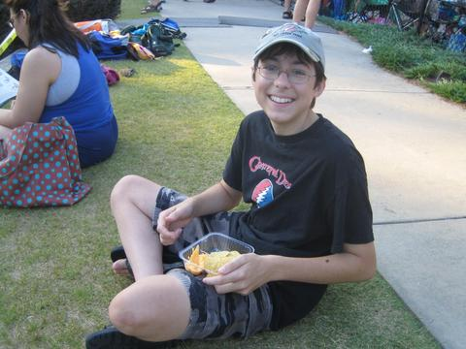

Alexi J. Owens Scholarship

The scholarship covers the cost for one swimmer’s dues for one season.

Criteria:

The athlete must be a resident of Flowers Crossing or Flowers Crossing At The Mill.

The athlete must have demonstrated commitment to the swim team by participating in at least one season prior to the scholarship year.

The athlete’s parent must have fulfilled their volunteer hours with the swim team during the past swim season.

The athlete must write an essay of explaining why they would like to be supported by this scholarship, their character traits, and how they will represent the swim team. It is recommended that the essay be no more than 200 words and age appropriate.

Application process: Athletes should submit the application by 5/22, essay and personal reference to 905 Connell Lane, Lawrenceville, GA, 30044. Attention: FCST

Selection process: All applications will be reviewed for completeness and accuracy by the scholarship donating committee. The scholarship winner will be announced at the 1st home meet on 6/1. The selection is not based on financial need.

Flowers Crossing Swim Team
Mighty Marlins
Alexi J. Owens Scholarship Application

Athlete’s name_________________________________________________

Street Address_________________________________________________
City, State, Zip Code____________________________________________

Date of Birth__________________________________________________

Number of years on the Flowers Crossing Swim Team_________________

Do you understand the criteria and agree to meet the volunteer requirements?_____

Name______________________________________

Signature/Parent if under 18 years old_______________________________

Date__________________________

Please attach a personal character reference, not from a swim coach.

