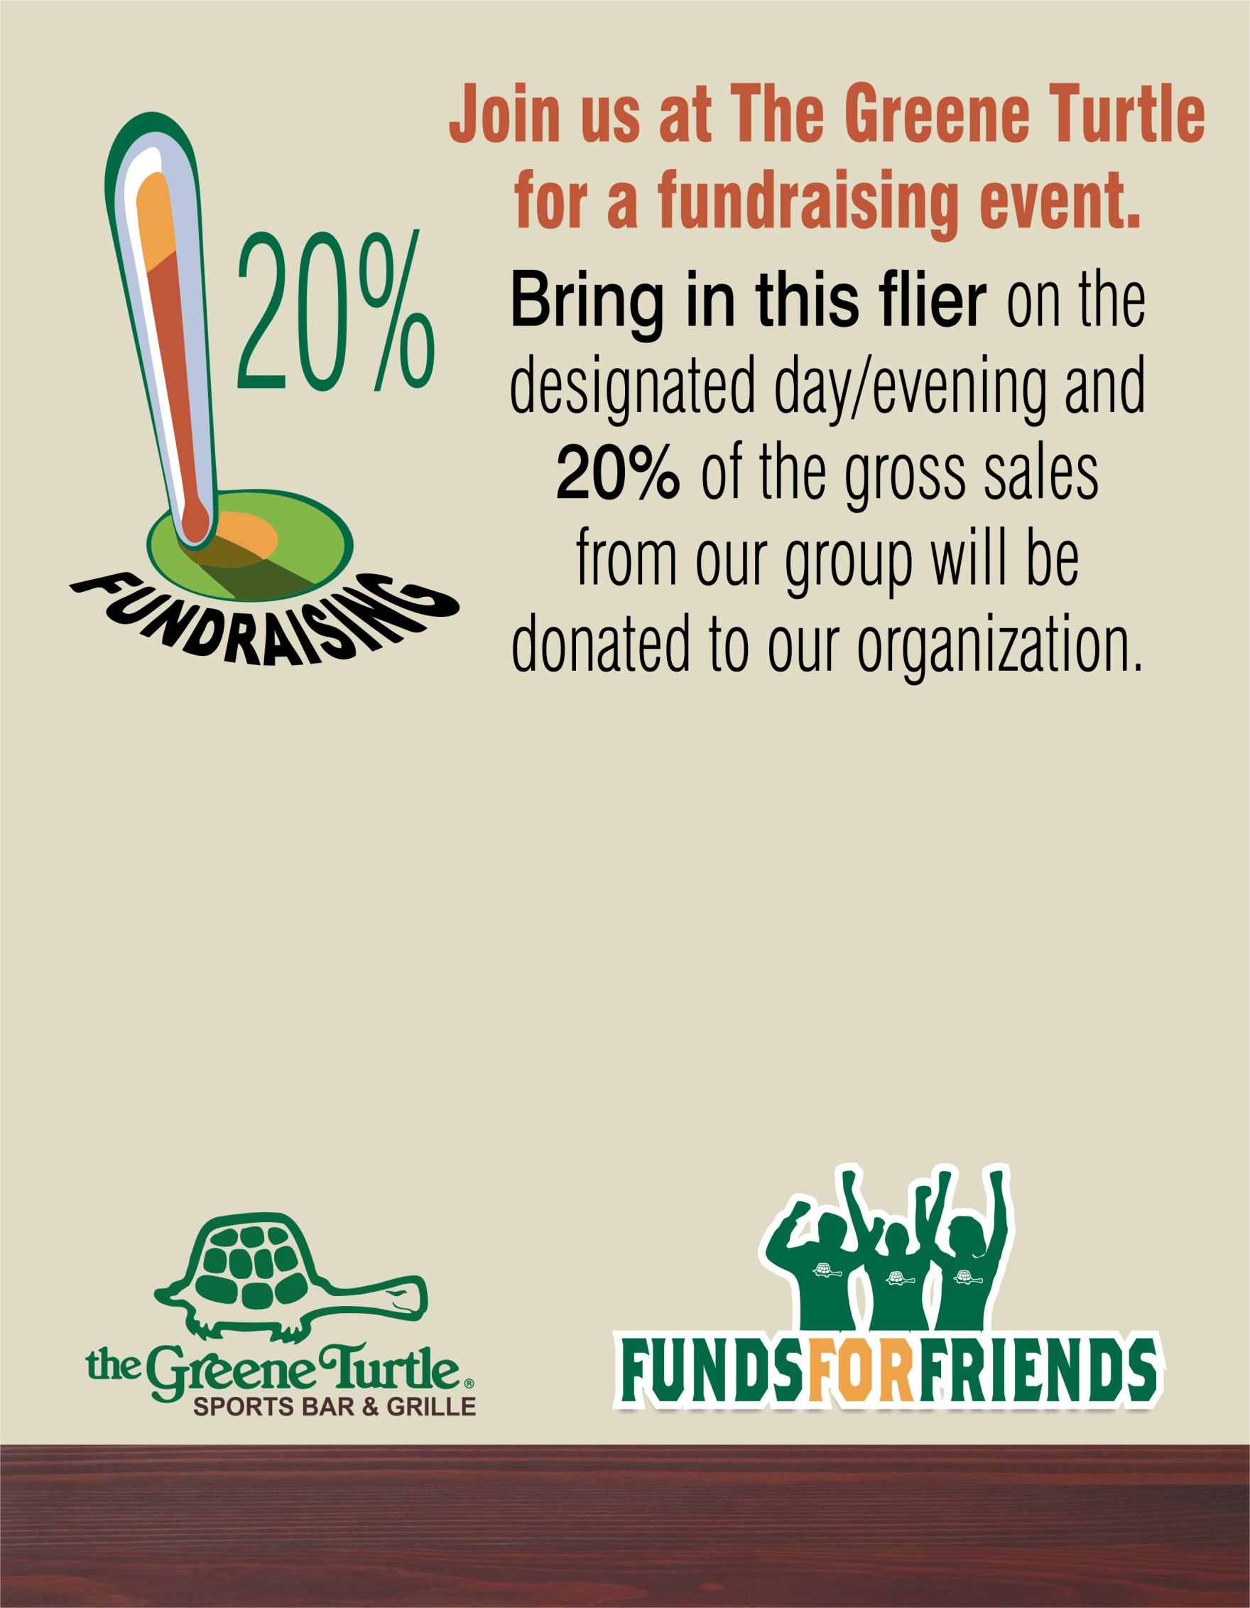
GROUP NAME: Herndon Swim League
DATE OF EVENT: Tuesday July 19th, 2016
MEAL PERIOD: Lunch, Dinner, Carry out
4301 Chantilly Shopping Center, Chantilly, VA
www.thegreeneturtle.com

