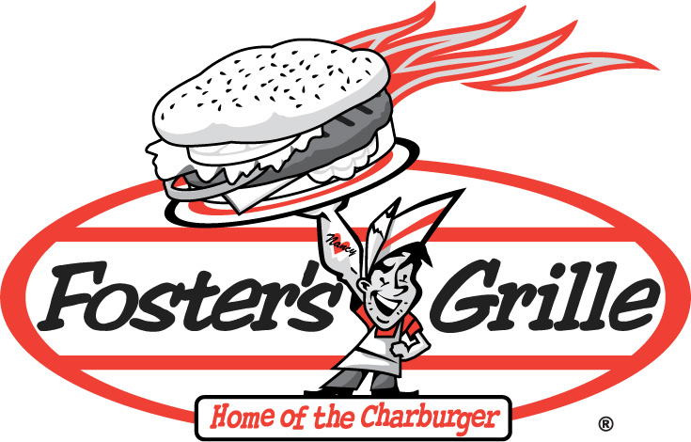
Foster’s will donate 20% of all proceeds from sales generated by your event back to your school or organization. It’s a great way to raise more money and have fun doing it.
Donations based off voucher sales during specified time.
Tax revenue not included.
Dining for Dollar$
F
O
S
T
E
R
S
G
R
I
L
L
E
.
C
O
M
Come out
Thursday July 7
And help support
Four Seasons Swim Team

4 pm – 9pm
Foster’s Grille
905 Herndon Parkway
Herndon, VA 20170
703-956-6231
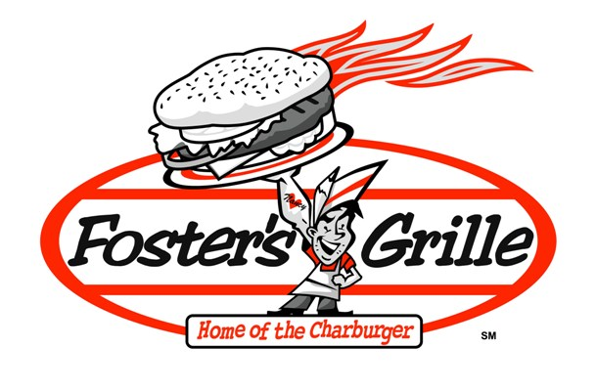

Detach and present this voucher for full redemption

