Braun Station Barracuda Registration 2017
2017 Returning____ New____
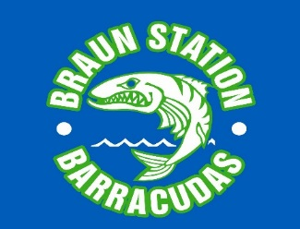
Swimmer T-Shirts
Swimmer 1:______
Swimmer 2:______
Swimmer 3:______
Swimmer 4:______
Extra Paid T-Shirts:

For Office Use Only

Swimmer/s Name/s:

- Last name:____________________ First name:_______________________ MI: ____
Gender: M or F; DOB: __________________ Age as of May 15, 2017: ____

- Last name:____________________ First name: _______________________ MI:____
Middle Initial is required in the Maverick League!
Gender: M or F; DOB:__________________ Age as of May 15, 2017: ____

- Last name:___________________ First name: ________________________ MI:____
Gender: M or F; DOB: Age as of May 15, 2017: ____

- Last name:___________________ First name:_________________________ MI:____
Gender: M or F; DOB: Age as of May 15, 2017: ____

Parent/Guardian Names (s):

Email Address (very important)

Phone #’s: Home Cell

Address:

State Zip Neighborhood

Swimmers must commit to each meet by 5 days prior to the meet. Swimmers not committed will not be built into the meet.
************************************************************************************************************************************
Each Swimmer will receive a FREE shirt!! – Additional T-Shirts are offered at $10.00 each

FREE: One T-shirt/Swimmer Swimmer 1: YS, YM, YL, AS, AM, AL Swimmer 2: YS, YM, YL, AS, AM, AL
Swimmer 3: YS, YM, YL, AS, AM, AL Swimmer 4: YS, YM, YL, AS, AM, AL

Adult T-Shirt: $10/shirt or $12/tank 1. Specify T-shirt or Tank: AS, AM, AL, AXL, AXXL
2. Specify T-shirt or Tank: AS, AM, AL, AXL, AXXL
************************************************************************************************************************************************************** FOR OFFICE USE ONLY
Registration 1st Swimmer: $100
Credit Card Use Fee:
Up to $200 : $6
$201 to $300: $9
$301 and up: $12
2nd Swimmer: $95
3rd Swimmer: $90
14 yrs. And Up: $75

Concession Fee $20.00/family

TShirts ($10 each)/Tanks ($12 each)

Out of Neighborhood Fee (if applicable) $20.00/family

Late Fee (after May 15, 2017) $25.00/swimmer

TOTAL Check # _________Cash ___________Credit_________

*****Make all checks payable to BSST or Braun Station Swim Team. No refunds after May 23rd. *****

