Monday, June 8

Help support Medlock Bridge Swim Team!
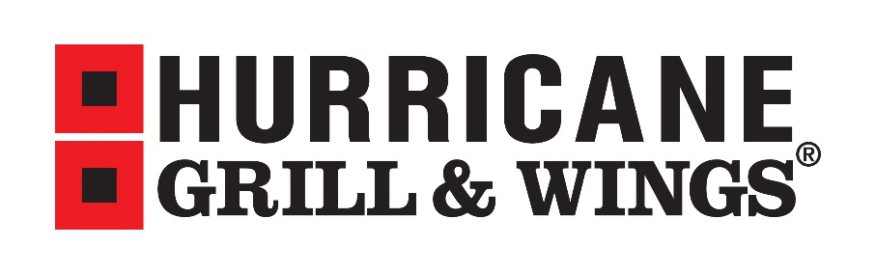
9700 Medlock Bridge Road #120, Johns Creek, GA 30097
in Regal Cinemas Shopping Center

From 6-8pm on Monday, June 8, let the cashier know you are at Hurricane Grill & Wings to support Medlock Bridge Swim Team and 10% of your purchase will be donated back to our swim team for the purchase of our new record board.

Thank you for your support!

