MEDLOCK BRIDGE BARRACUDA
SWIM TEAM T-shirts 2015

Orders & payment due by May 8. If you don't see Jonna Pointer or Carolyn Cunningham at practice, please email Jonna at jonnap76@gmail.com with your order.

Adult Pocket Tee $18
Sizing: Adult XSmall – 3XL

Kids Tee (no pocket) $15
Sizing: Youth S-Youth Large

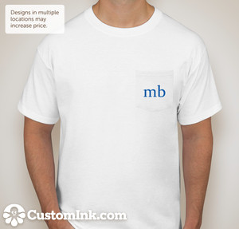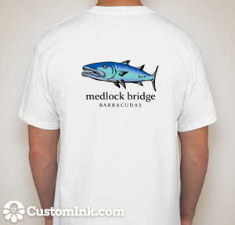

Tank Top $18
Adult XS – XL

