Speedo Echo Energy Back (1 Year Suit)

Made from 15% Lycra Spandex and 85% Polyester for a comfort fit.
An affordable suit without hurting your wallet
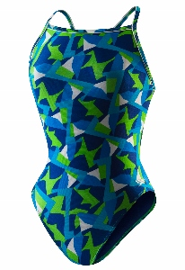
Price $36.44
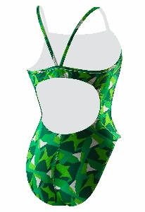

Speedo Echo Jammer

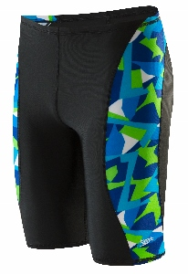
Price $28.84

