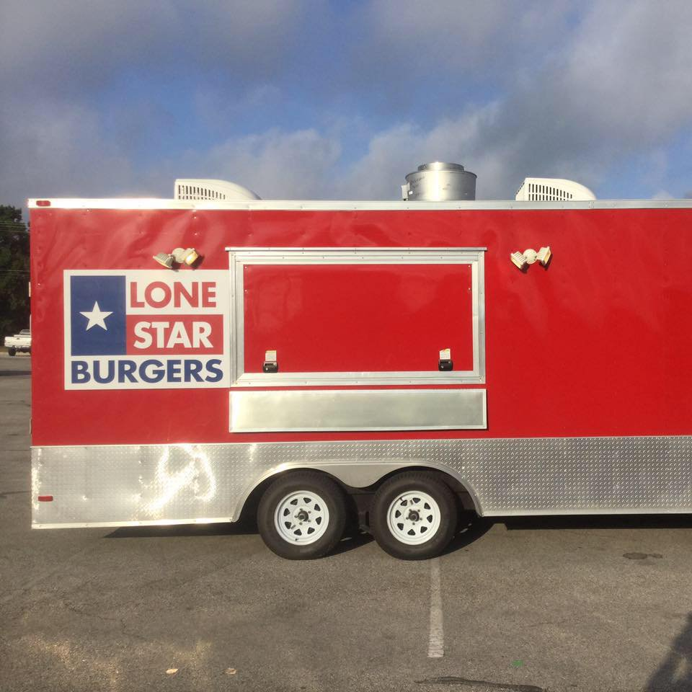
LONE STAR BURGERS FOOD TRUCK
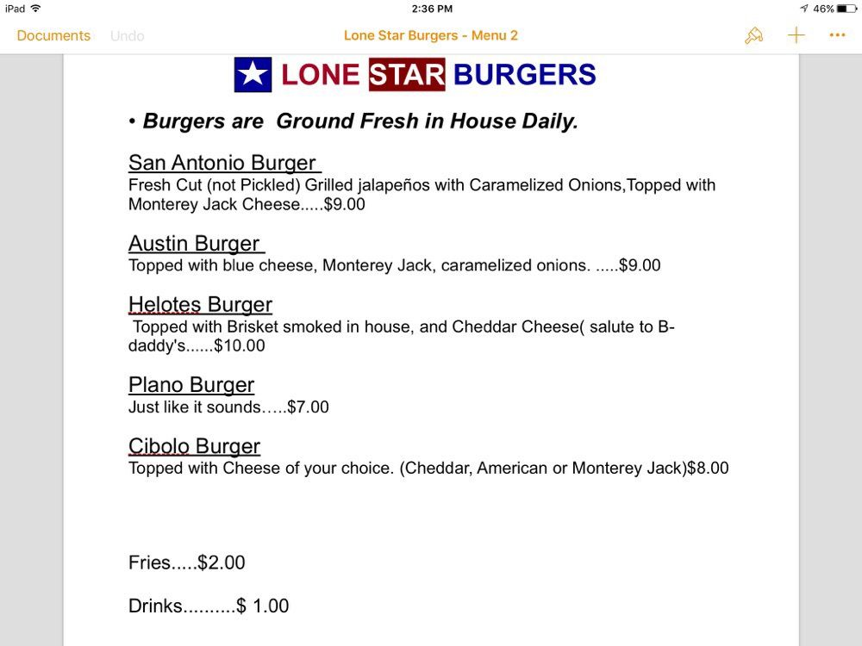
Fresh-baked buns, daily ground meat, & creative toppings = Delicious Burgers for you!
Sells sodas, bottled water & Gatorade.
Form of payment accepted: CASH
Credit cards:

