FOOD TRUCKS AT CHAMPS MEETS
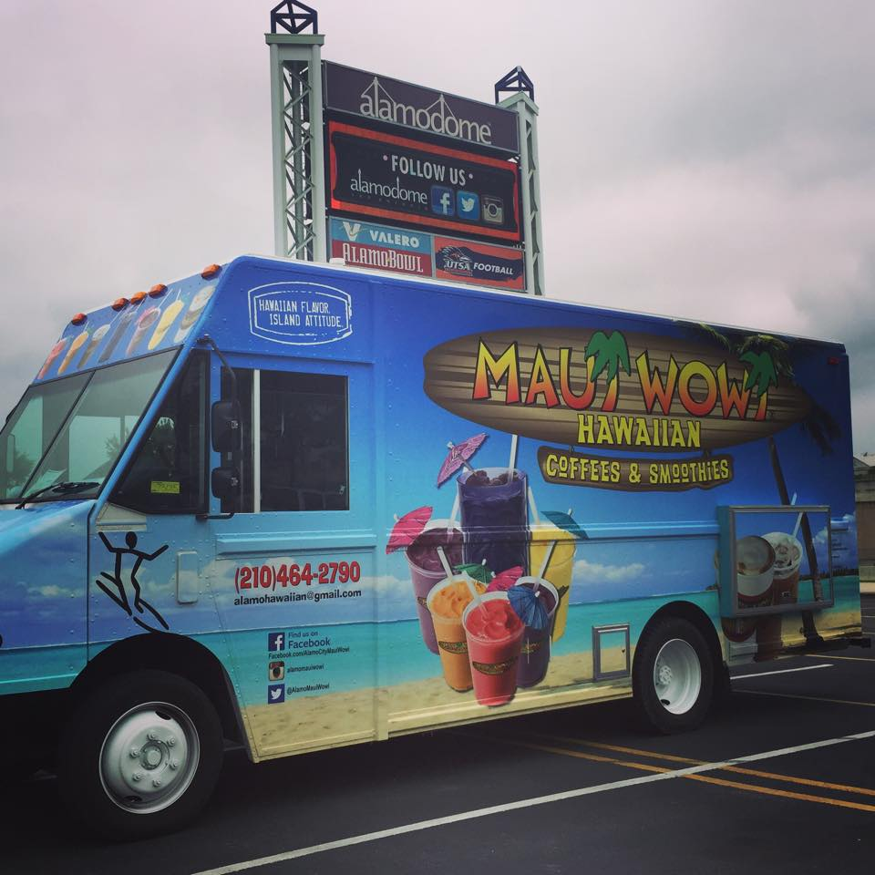

Serving:
Famous Kona coffee $3
Lattes $5 (vanilla, hazelnut, or caramel)
Fresh fruit smoothies (all natural, gluten free, real fruit, made with nonfat yogurt and whipped with a fresh banana—flavors strawberry, mango-organce, black raspberry, pina colada, kiwi lemon lime, lemon wave (dairy free item no banana) priced at $5 sm, $7 reg, $10 tiki with refill for tiki $6
Bananas
Muffins
Cookies
Truck accepts: Mastercard, American Express, Discover and CASH

