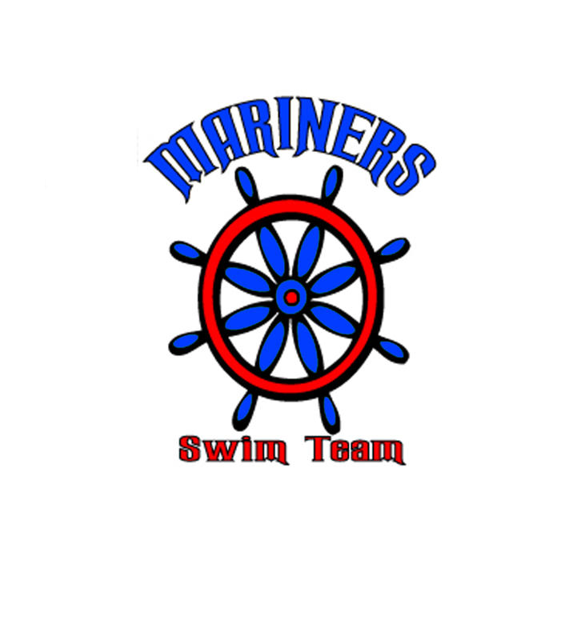
MARINER MINUTE 7

Way to go Mariners!! It was a great weekend! Our team did a fantastic job coming together and supporting the whole team on our last dual meet before Divisionals.
Divisionals will be held on June 18th at Klein High School. We have to be there at least by 12:45 to get yourself checked in, find the team and get ready for warm ups. Our warm ups are at 1:30 and the meet will start at 3pm. We will have an area for us to be together as a team so please come and find us.
The volunteer of the week is Sandra Alcaraz!! Thank you Sandra for all you do!!!!

A Message from the President
Thank you to all families for being flexible, open minded and understanding for all the practice and meet cancellations due to weather. It's been hard, but seeing our swimmers Saturday was such a joy to see everyone have improvements and smiles!!!!

The sign up for Ponderosa and All Stars last day is this Saturday. Please find Edris for more information. Eligibility for both end of season invitational meets are on the Mariner website - http://colonycreek.swim-team.us/. You can still qualify for these meets at divisionals, but all entries are due to Edris Howe by the end of the divisional meet. All individual events cost $5 each. The Mariners will pay for relay events.
Times that qualify are in green on the report and the qualifying times for each event are in the headers.
Our Year end party at ITZ Family Food and Fun is from 5-8pm. on June 20th. This is the time the swimmers get their awards and recognitions for the season. Just a reminder, the team will be pay for the swimmer’s entrance only.
Lastly, if you are interested in being on the board, we will have elections at the yearend party. You can approach Edris with any of your questions about getting on the board.
Coaches’ Corner
Good meet Saturday! Even with the lack of practice, we still had huge time drops!!! Watching our kids swim and seeing what they have accomplished this season is always a reward for me as a coach. A few kids accomplished actually swimming in deep water for the first time.
If you are NOT swimming at Divisionals, your last day of practice was last Friday.
As we close our regular season this Saturday it has been a very FREAKY swim season to say the least but the kids have done an amazing job with what time we had in the water.
Please be on time for practice as we have a lot of work to finish before Saturday.
Parents, Thank you for your support and dedication to your children.
The mariners took 1st place at summer thunder and Jade Phillips set a new 50 fly record at pentathlon!

www.http://colonycreek.swim-team.us/

