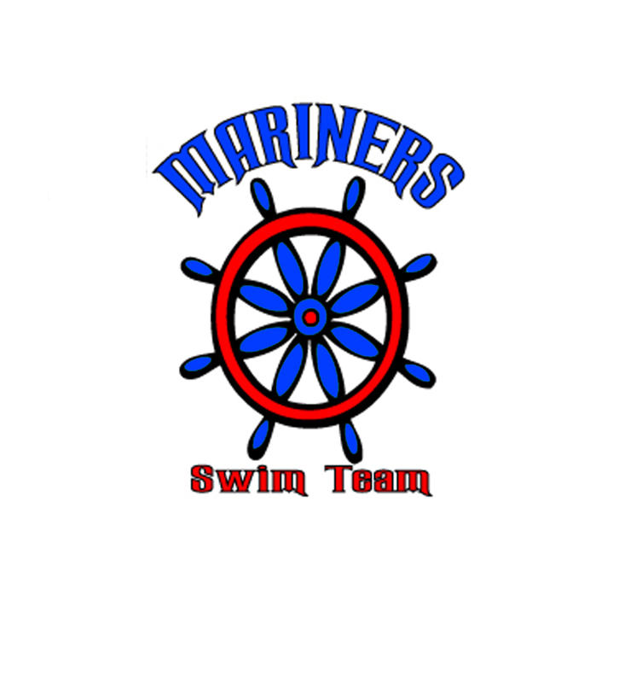
MARINER MINUTE 4

What a meet!!! The team got together and swam like a team. Unfortunately, we lost by 2 points but it was a great meet. Thanks to all the volunteers who helped out.
This week we are at Kleinwood which is right down the street. Go south on Louetta to Kleinwood Dr. and make a right. You can park at the church which across from their pool. Please leave the first 6 parking spaces empty and a parking spot that says “Williams” since that is for the church patrons. We can set up on the south side of the pool area next to the tennis courts. Please be there by 7:00 to sign in and be ready to warm up.

Remember, after every meet, we will meet at Fuzzy’s Tacos around 4pm. This is a time for the team to get to know each other and unwind after a long day. Fuzzy’s Tacos is located in the Vintage.

Volunteer Coordinator
Please check your email for shifts that need to be filled or if you need to find out if you are working this meet.

Coaches Corner
Our meet Saturday was one of the best meets we have had in a while.
We could see all the hard work we have been doing and glad everyone did a great job. We fell short by 2 points but keep up the good work. We will be on weather watch this week as the weather has rain every single day. Our next meet is at Kleinwwood and as I am working on meet entries please make sure you have signed the book if you cannot be there Saturday.

A Message from the President
Mariner Families, please check your file folders for ribbons and such. Keep a look out for information on divisional. Also reminder on invitational meeting is on May 30th. If your swimmer has qualifying times, please be there at the meet. If you are unsure of their qualifying times, please visit www. nwal.org.

