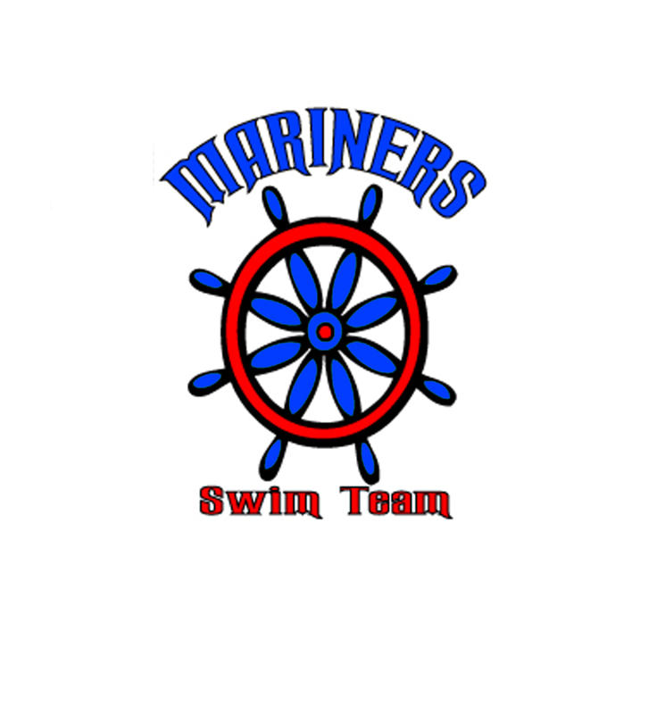

I need to start by saying thank you to all our volunteers who stepped up when we needed the extra help. The team wouldn’t be able to function without families like you.
This week we are at Lakewood pool which is off of Louetta. Please check the website for directions. Make sure that you are at the Lakewood pool by 7:15 so you can check in with your tent moms and circle in on the board. That way you are not scratched from the meet. We will practice before the meet, so listen for the coaches’ instructions.
Please bring sunscreen and keep yourself hydrated all day.
Here is some helpful information on where to park and where to find the team.
Parking is in the Lakewood lot and along the streets. Also, The Woods School across the side street (across from the tennis courts behind the pool) has a lot that can be used. Warm up time is 7:45. Start time 8:30. Visiting team set up is in the grassy area on the side of the pool closest to the parking lot. Kiddie pool, playground and sand volleyball courts are closed during the meet. They have a great concession. They have a big grill where we cook chicken, burgers, sausage. They have grilled chicken Caesar salad, pasta salad, fruit salad, donuts, kolaches, breakfast burritos, candy, drinks, etc. The address of the pool is 15006 Lakewood Forest Dr, Houston, 77070.

Remember, after every meet, we go to Berryhill at 4pm. This is a time for the team to get to know each other and unwind after a long day. Berryhill is on Champions Forest right before you get to 1960.

Volunteer Coordinator
Please check your email for shifts that need to be filled or if you need to find out if you are working this meet.

From Wally's Bear Cafe
I would like to thank all the concessions volunteers on scene and behind the scene for their continued support. We had an awesome meet in sales especially in the Nacho department....OMG 2 1/2 cases of Chips. That's a whole lot of Macho Nacho. Please remember we have one more home meet and then Divisionals which we are serving lunch at this year. We will need all the help we can get!! Thank you again for all your support!

A Message from the President
The Mariners’ board will have 3 openings at the end of the season. Please speak to a board member if you are interested. Our election is at our year end party.
We have a new website coming. Become a member of Facebook for any updated information and details of the team.
Here is more clarification on how invitationals work. If you are still confused, please see any Mariner board members. We usually wear tye dye shirts at the meets.
There are 4 invitational meets in our area. The meets are sponsored by summer league teams or year round swim clubs as fundraisers. Since they are fundraisers, there are fees collected for each event for each swimmer to participate.
These invitational meets are not open meets. To be invited to swim, you must have qualifying times in events. The qualifying times can be obtained by going to www.nwal.org and click on the particular invitational meet or through our computer volunteer. The heat sheets that are sold at meets typically list the times needed so that a swimmer knows what qualifying times to work toward.
Pentathlon is an invitational meet, held on a Sunday and typically scheduled with 10 and unders swimming in the morning and 11 and ups swimming in the afternoon. The downside is that it is a Sunday. The upside is that times acquired at this meet help swimmers get closer to qualifying for other invitational meets. The other upside is that the swimmer gets experience swimming in an indoor, high school 8 lane pool.
Summer Thunder is another invitational meet. This meet is held during the normal swim season over 2 days, a Sunday evening and a Monday. The downside is that it involves weeknight evenings and can be late nights for working families. The upside is that times acquired at this meet help swimmers get closer to qualifying for other invitational meets. The other upside is that the swimmer gets experience swimming in an indoor, high school 8 lane pool.
Qualifying swimmers can participate in Pentathlon and Summer Thunder, but it will be the swimmer’s responsibility to pay the fees for individual events. The Mariner Board will pay for relays at Summer Thunder. Deadlines for payments will be made available to interested swimmers.
Two other invitational meets that occur after summer league season are All Stars and Ponderosa. They are held the Saturday and Sunday after our divisional swim meet. These meets typically have harder qualifying times. The meets are held the same weekend. Qualifying swimmers can participate in All Stars and Ponderosa, but it will be the swimmer’s responsibility to pay the fees for individual events. The Mariner Board will pay for relays. Deadlines for payments will be made available to interested swimmers.

Coaches Corner
This week’s meet is on a holiday weekend. IF YOU ARE NOT PLANNING TO BE THERE, PLEASE WRITE YOUR NAME IN THE SPIRAL NOTEBOOK. There were lots of swimmers that left during the meet and didn’t tell the coaches that they needed to leave early. It’s a big help when you tell us because it saves us looking for other swimmers to take your place in relays. Also, plan on being there most of the day on Saturday since Lakewood has a 4 lane pool. We will only have A and B relays so we can make the meet go a bit faster.
We had a fun meet and exciting meet and we are happy to see the kids learning and willing to learn how to swim.
This week at the meet, we will be giving out Cici's coupons for IMPROVED times for the 10 and unders. So make sure you stop at our tent to see if you improved on your times!!
Also, for divisionals: if your times are not under a minute and you are in the 6 and under group, you will not be able to swim at it.

Sponsorship
I will start pre- ordering Divisional t-shirt starting on Saturday! See Lisa or Gigi for information
Please make sure you are checking your family folders for updates and information and your pictures after they come in.
If you registered late and want a t-shirt, we can still order shirts for you. Just see Lisa Sartor for more information or email her at
sartorfam@sbcglobal.net
It’s not too late to be a Mariner sponsor or bring in sponsors! Only $35 for business card ad. and $ 250 for full page & thank you plaque. Lots of options in between!
Call Lisa Sartor for more info 830-832-9227

www.swimmariners.com

