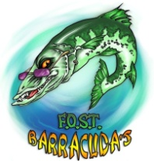
Pledge sheets due back on June 10th at practice.

Cudathon Pledge

June 2nd, 2015
First Name: Last Name:
My GOAL is to swim at least laps.
Dear Potential Sponsor,
I am participating in our swim team’s annual Cudathon. Our Cudathon teaches us to set and achieve goal as we try to swim as many laps as we can during our practice. All proceeds raised will benefit the Forest Oaks Swim Team’s goal to replace our starting blocks. You can sponsor me for any dollar amount per lap or you can put a maximum amount that you are willing to contribute. After the Cudathon, I will return to tell you how many laps I swam and collect your contribution. Make checks payable to FOST. All contributions are tax-deductible.
Thank you!
Name of Sponsor |  | Pledge per Lap | Maximum Pledge | Amount Collected from Sponsor | Cash or Check
1
2
3
4
5
6
7
8
9
10
11
12
13
14
15
16
17
18
19
20

