Youth Extra Small $10 | Youth Small $10 | Youth Medium $10 | Youth Large $10 | Youth Extra Large $10 | Adult Small $15 | Adult Medium $15 | Adult Large $15 | Adult Extra Large $15 | Adult  2X Large $15 | Adult 3X Large  $15
Division 3 T-Shirts 2016
Swimmer Name
Swim Team
 | Quantity | Total
Adults @ $15
Youth @ $10
 | Total
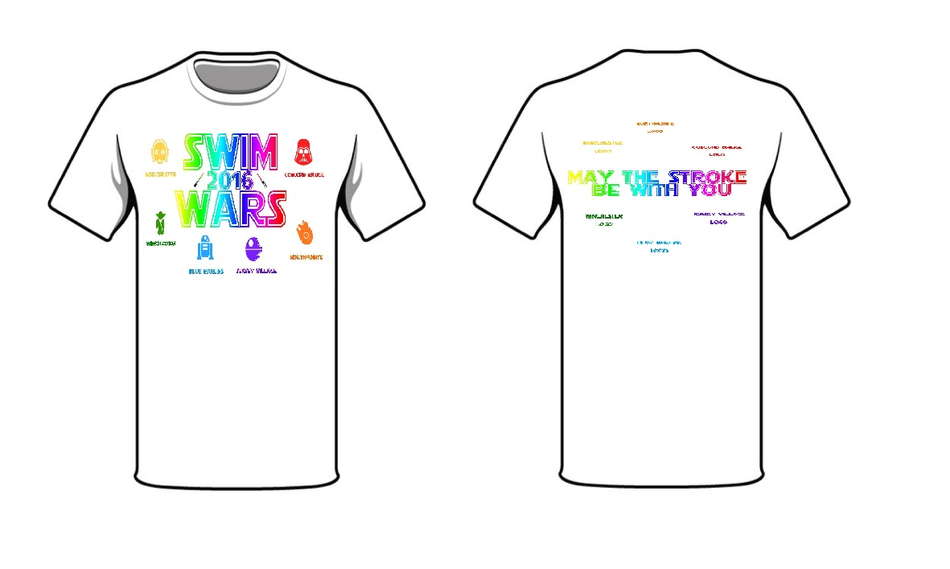
All pre-order sales are final. Limited sizes will be available for purchase at divisionals on June 18th. Please have pre-orders turned in by June 12th to CBST.

