Divisional Meet
Team Parents Check In: 6:30 a.m.
Swimmer Check In: 6:45 a.m.
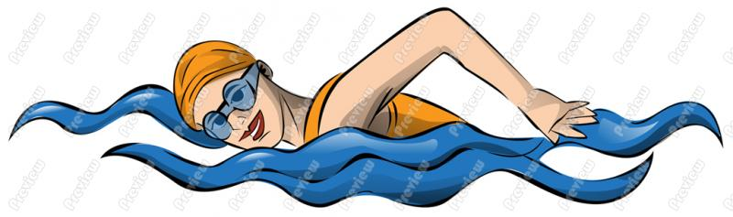
Our team set up is tight, so please try to buddy up if possible.
Don’t forget to stay hydrated!!
It will be a long day.
1911 Bellchase Dr, Spring, TX 77373
- Head toward Bellchase Cir on Bellchase Dr. 521 ft
- Turn left onto Aldine Westfield Rd. 4.1 mi/6.5 km
- Turn left onto FM-1960 W. 347 ft/106 m
- Continue on FM-1960. 17.8 mi/28.7 km
- Turn right onto Crosby Huffman Rd (FM-2100). 5.8 mi/9.3 km
- Turn right onto N Diamondhead Blvd. 0.9 mi/1.4 km
- Turn left onto Golf Club Dr. 1.4 mi/2.2 km
- Turn right onto Newport Country Club Dr. 0.5 mi/821 m
- Your destination on Newport Country Club Dr is on the right. The trip takes 30.6 mi/49.3 km and 48 mins.
16401 Country Club Dr, Crosby, TX 77532-5048

