2014 C-2 DIVISIONAL T-SHIRTS
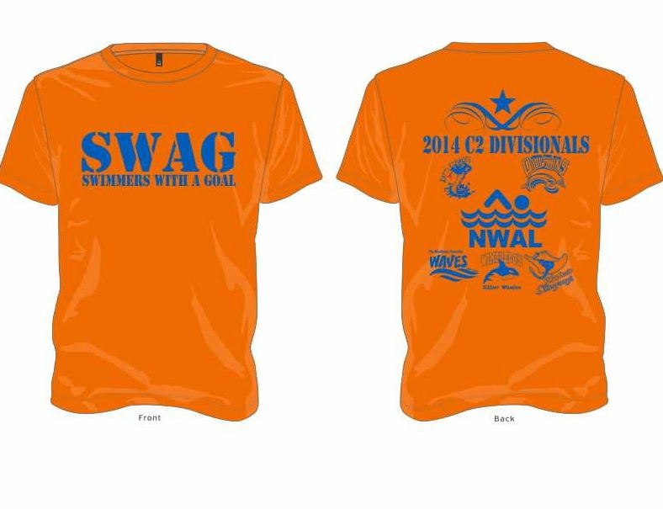
PRE-SALE $10 , tanks $12
($2 extra for 2XL-3XL)
Please note: On the day of divisional, sizes will be limited. Cost will be $15 (no tanks available). Preordering is recommended
__________________________________________________________

PRE-ORDER FORM
NAME:_______________________________________

Youth: Small_______ Med_______Lg_______XL_______

Adult: Small_______Med_______Lg_______XL_______
2XL_______3XL_______

Total:_______ X $10 (or $12 for tanks)=_______
+$2 for 2XL/3XL=_______

TOTAL DUE:__________________

