Waves Spirit Wear Order Form
Orders due by April 11, 2014
Orders should be emailed to Stevi Venable johnandstevi@gmail.com or 18 W Old Sterling Circle 77382
** Because of customization, we are unable to make exchanges after orders are placed**
ALL items will include the Waves Logo

Swimmer’s Name: __________________________________________ Total Amount ________________
Age Group: __________________________________________
Phone: __________________________________________ Paid by: _____________________
Email: __________________________________________

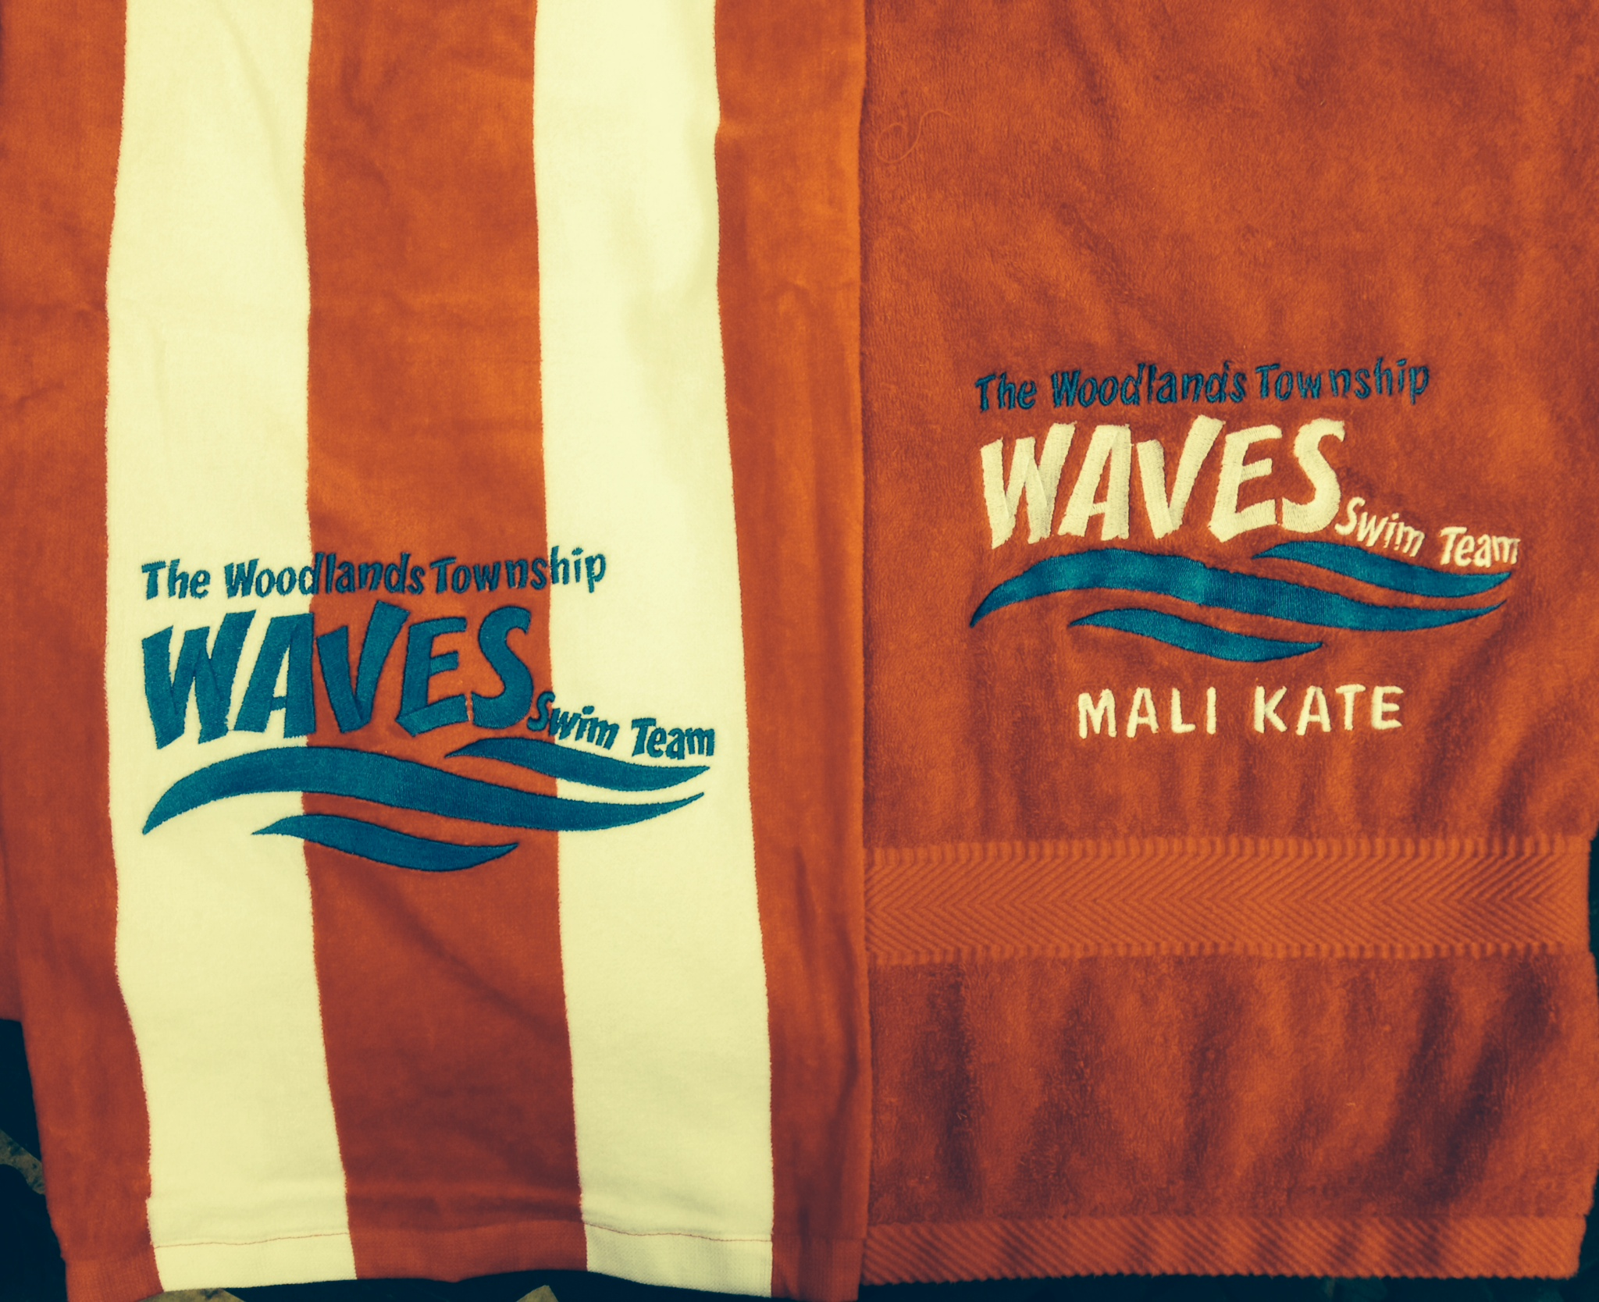 | Towel w/ Waves Monogram  (RED/White Stripe or Red)  30x60.. Red is Thicker than Red/White  ______ Qty @ $30 (RED)  ____Qty @ $30 (Red/White Stripe)  (Price includes 12 character personalization) | Personalization:  (max 12 characters)
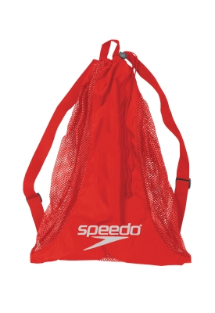 | Waves Swim Backpack (Red)  ______ Qty @ $23  (Price includes 12 character personalization) | Personalization:  (max 12 characters)
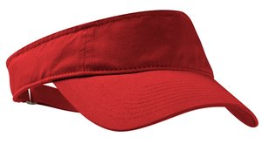 | Cotton Visor (White or Red)  White ______ Qty @ $12  Red ______ Qty @ $12 | No  Personalization  Available
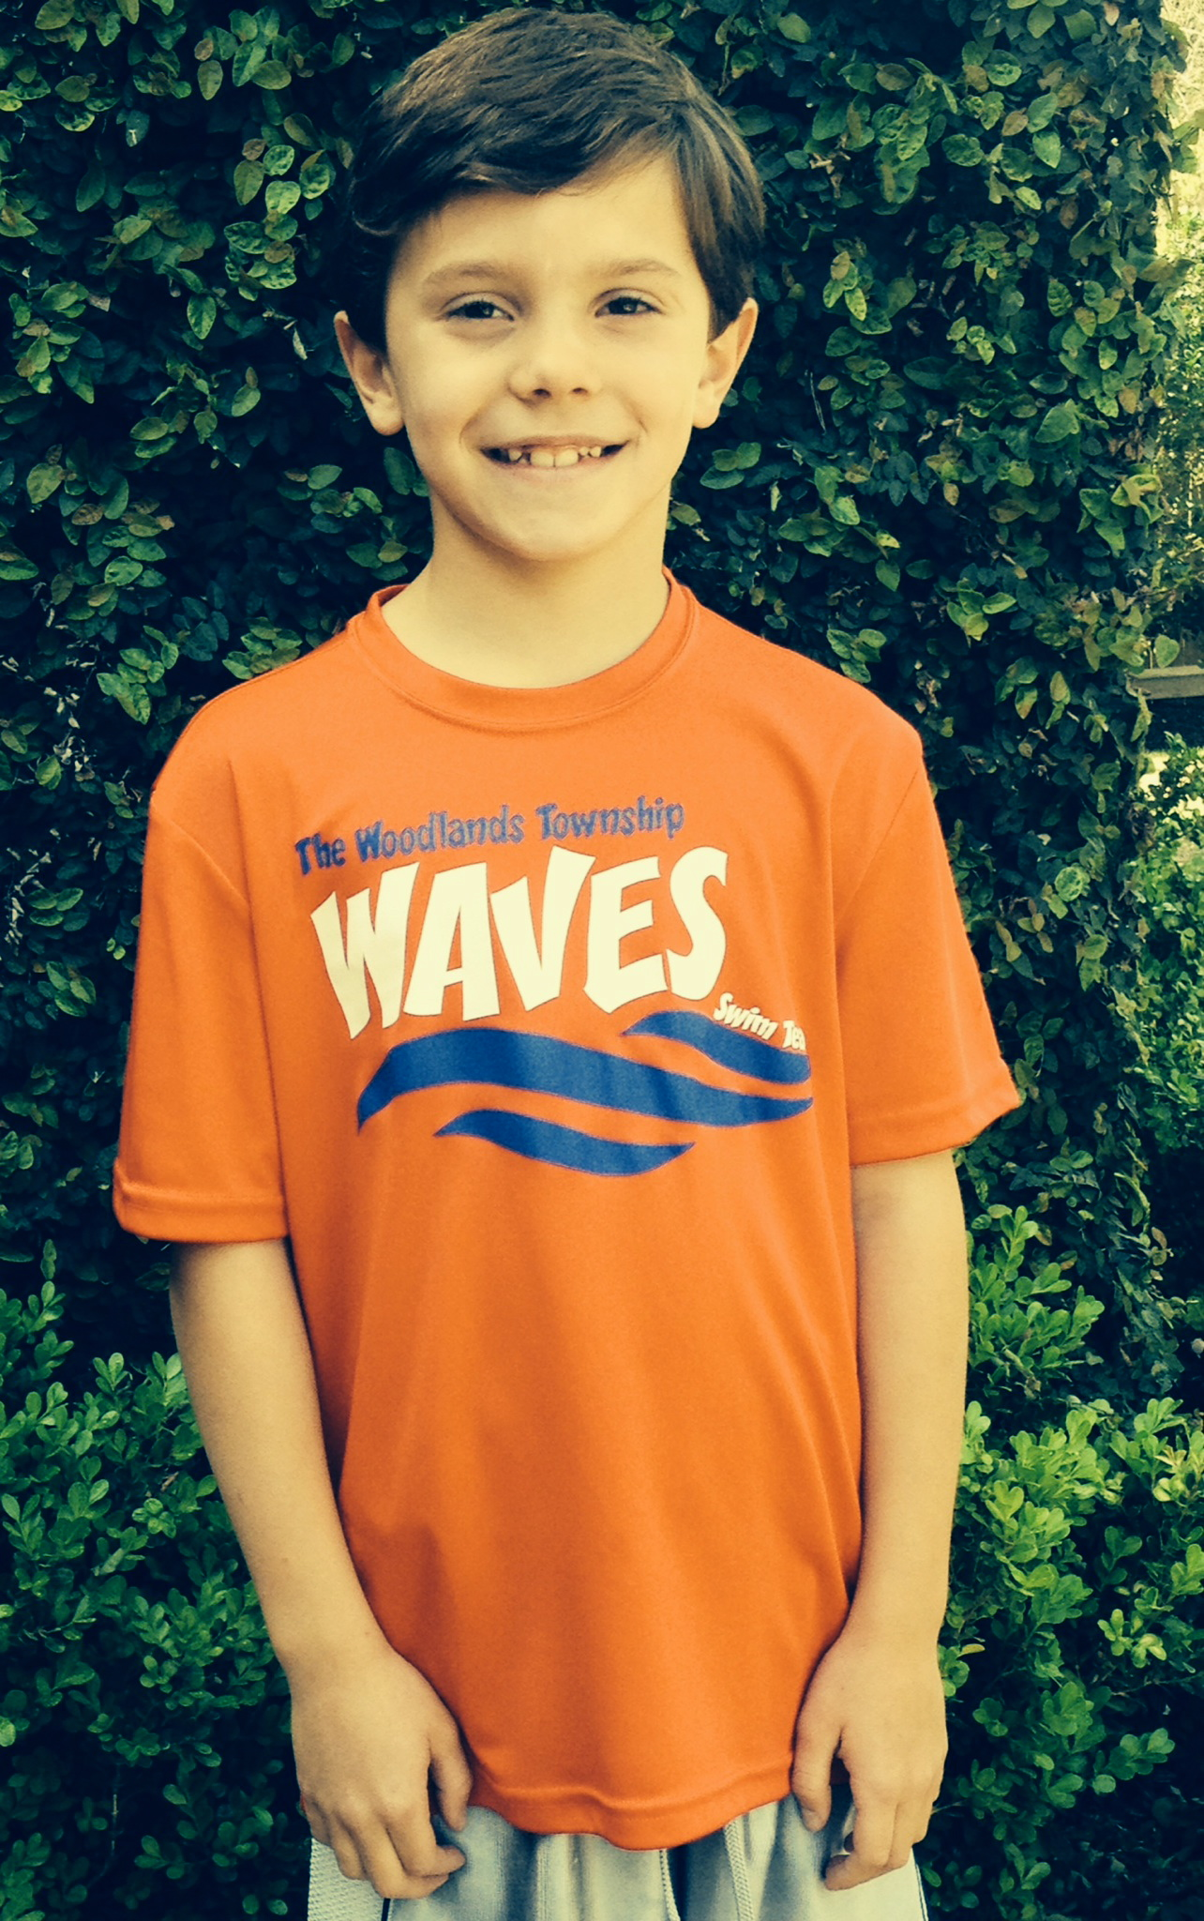 | Sport-Tek Spirit (RED) Shirt w/ Screen Print  ____Qty @ $20  Please indicate quantity of each size below:  Youth ____ XS (4) ____S (6-8) ____M (10-12) ____ L (14-16) ____ XL (18-20) ____  Adult ____XS ____S _____M _____L _____XL _____2XL_____3XL_____4XL
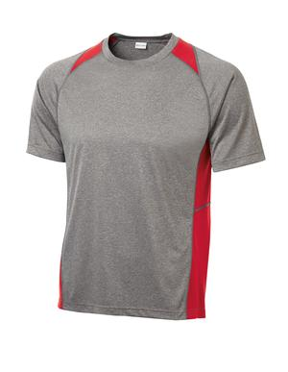 | Dry-Fit Colorblock Contender T-shirt (Grey w/ Red Highlights)  ____ QTY @ $22  Youth ____ XS (4) ____S (6-8) ____M (10-12) ____L (14-16) ____ XL (18-20) ____  Adult ____XS ____S _____M _____L _____XL _____2XL_____3XL_____4XL  **chest measure under arms XS 32-34. S 35-37, M 38-40, L 41-43, XL 44-46, 2XL 47-49,  3XL 50-52, 4XL 53-55
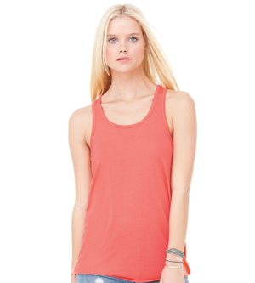 | Ladies Bella Flowy Racerback Tank (Red) with Waves Logo  (Bling or Screen Print)  Screen _____Qty @$23  Bling ____Qty @ $28  Please indicate quantity of each size below:  Adult ______XS ______S ______M ______L ______XL ______XXL
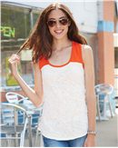 | Junior Burnout Tank w/ Waves Logo  (Red/White w/ Screen Print)  Screen Print ____ @ $25  Please indicate quantity of each size below:  Junior ______S ______M ______L ______XL  Junior Sizing: S (0-3), M (5-7), L (9-11), XL (13-15)
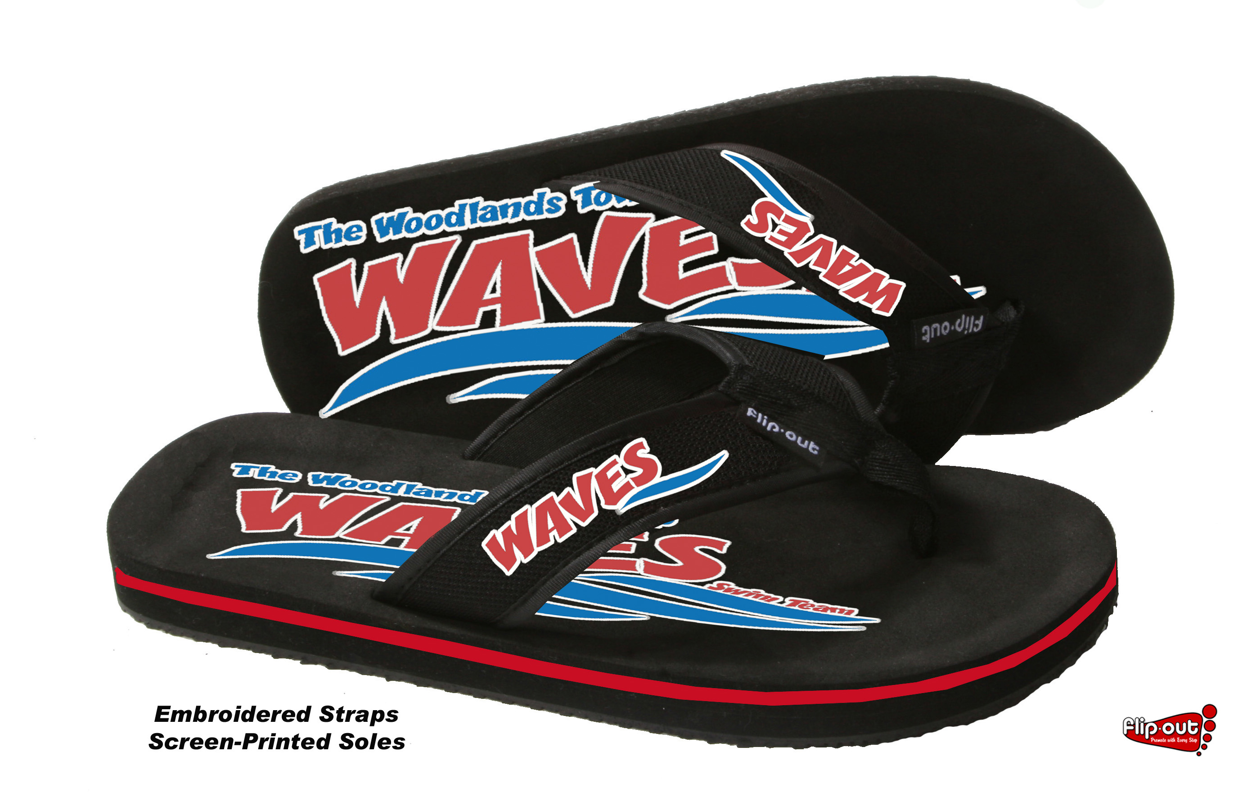 | Flip Flops $17.50  Embroidered Straps w/ Screen Printed Soles  See Flip Flop Order form for Sizing  ___________Qty _______________ Size
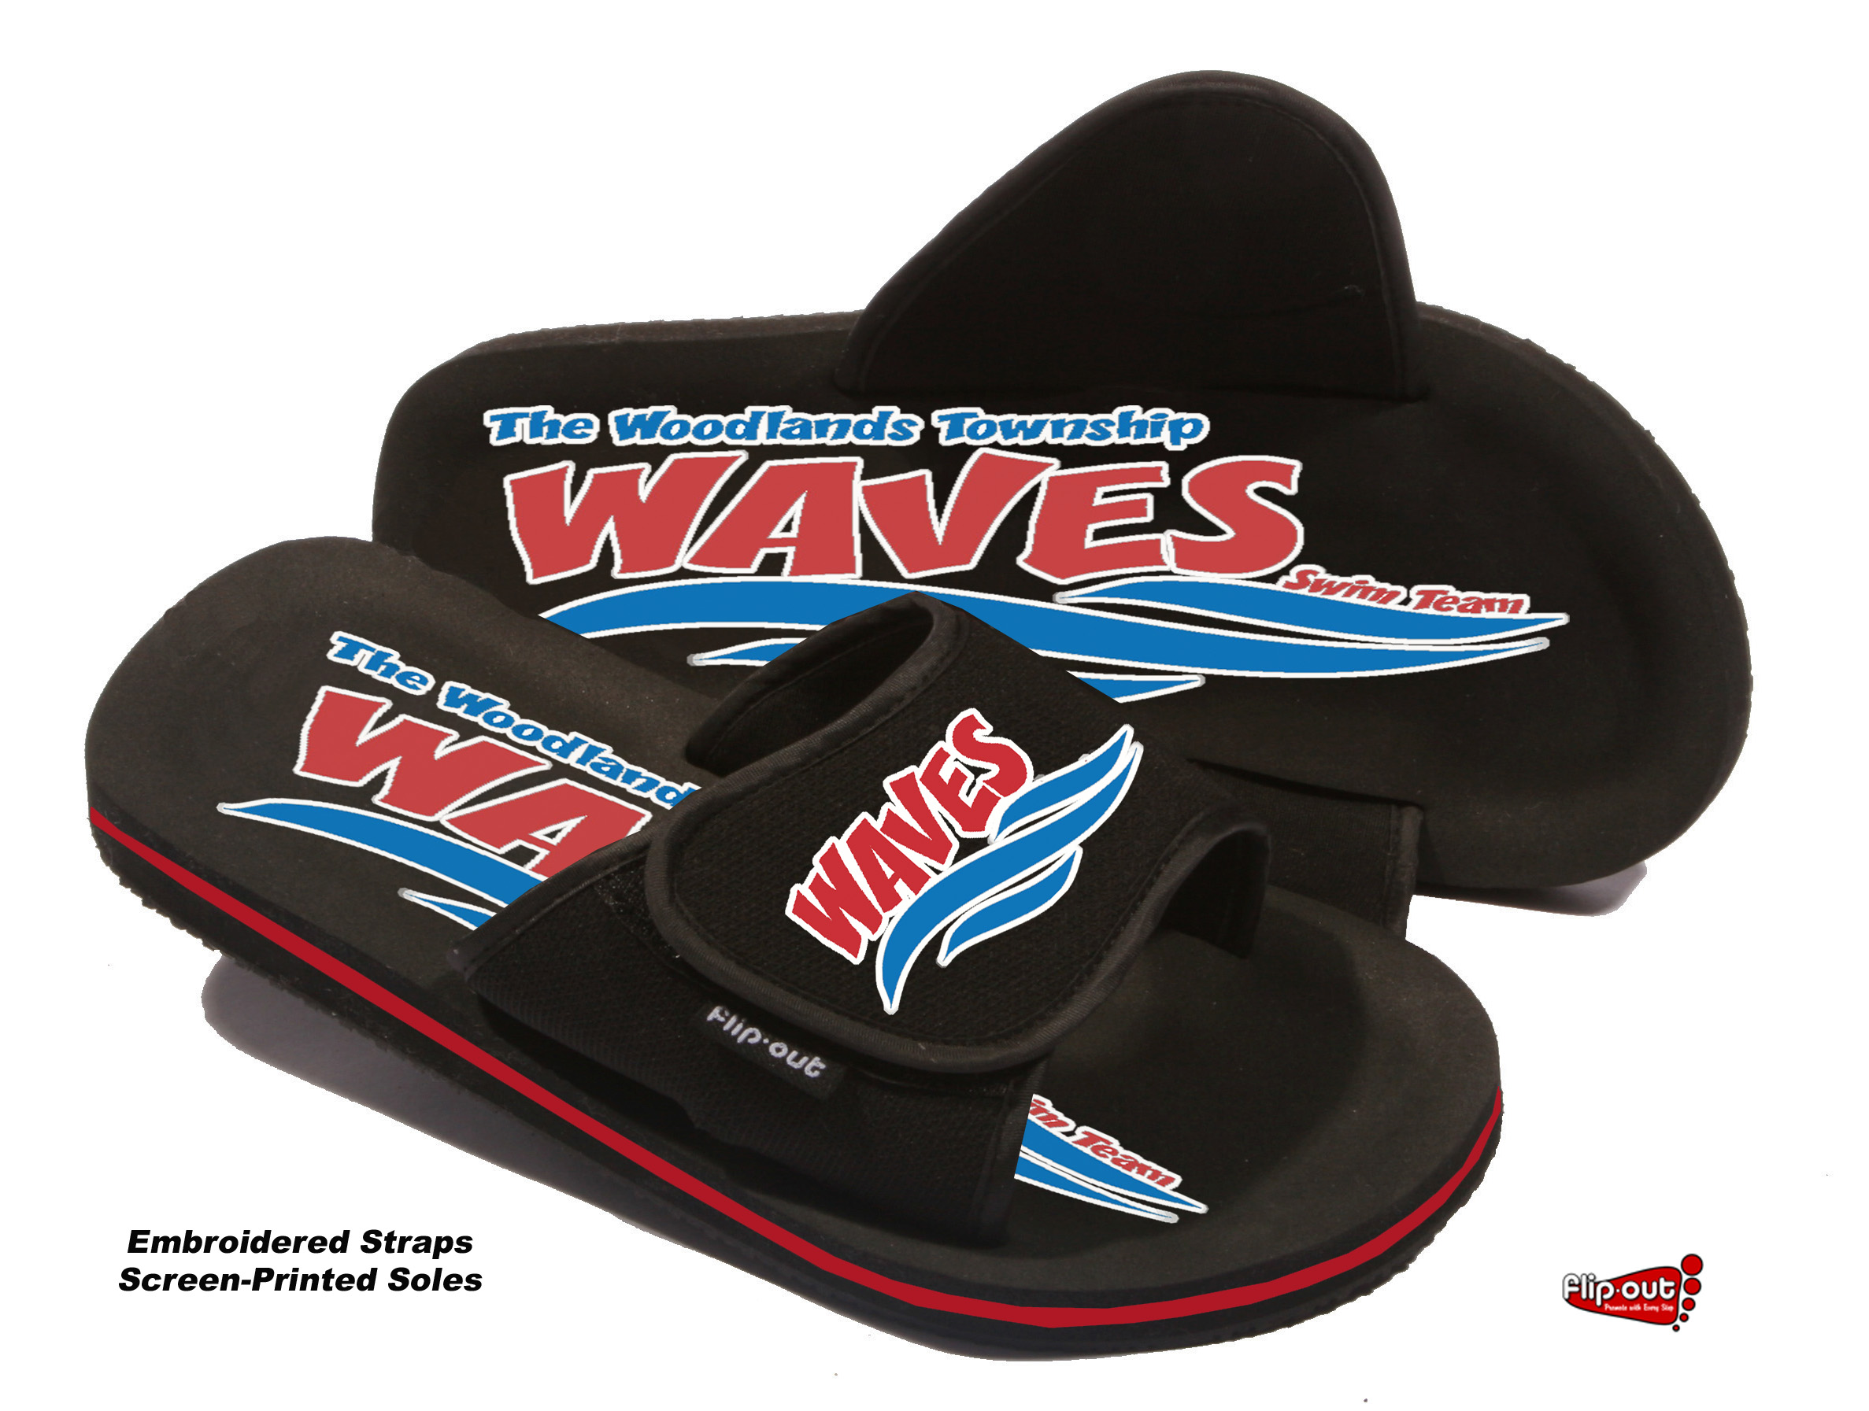 | Sliders $17.50  Embroidered Straps w/ Screen Printed Soles  See Flip Flop Order form for Sizing  ___________Qty _______________ Size  **In order for SLIDES to be available we must have over 50 pairs ordered. If you want slides please select and make note if you want Flip Flops if the Slides are not available**

