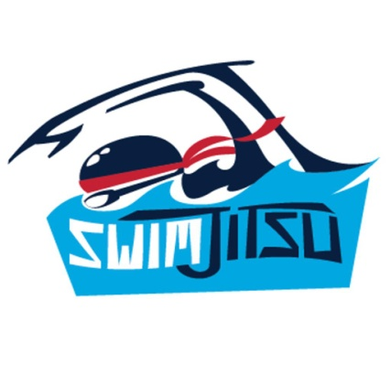

Cypress Fairbanks Swim Club brings SwimJitsu to Cypress, TX!

SwimJitsu is coming to the CFSC to challenge kids to conquer the mash-up of in water obstacle course and swimming skills on September 17th and 18th.

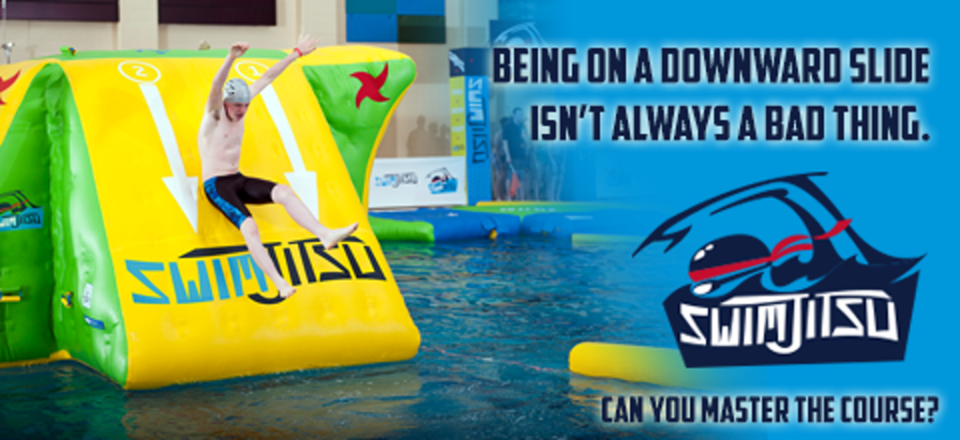

SwimJitsu participants, also known as “Swimjas,” aim to complete entertaining obstacles such as balancing across beams, swimming through trenches and cannonballing off the top of Mt. Swimja. Once participants conquer the course and the three sacred traits of speed, agility and wisdom, they can claim the title of Grand Master Swimja. SwimJitsu is fun for participants of all ages and skill, even those just beginning their swimming journey.

There will be four waves of two-hour sessions for participants to attempt unlimited runs on the course. Each timed shift requires a registration. Participants can register for one of the four waves:
• Wave 1: 9 a.m. to 11 a.m.
• Wave 2: 11:15 a.m. to 1:15 p.m.
• Wave 3: 2:30 p.m. to 4:30 p.m.
• Wave 4: 4:45 p.m. to 6:45 p.m.
Awards will be given at the end of each wave for the best times per age group. There will also be four ninja-themed swimming games for competitors to practice their newfound abilities. Advance registration is $35 per two-hour block per person. You do NOT have to be a USA or Fleet swimmer to participate!
To find more information on SwimJitsu visit www.SwimJitsu.com. To join the fun online, visit the SwimJitsu Facebook, Twitter and Instagram pages.

