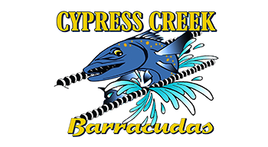
Calling all “Big Buddies”
Please use this pep rally time to
Get to know your little buddy

Calling all “Parents”
We will use this time to
Set up for Saturday’s meet

Pep Rally!!!
Friday May 23th, 2014
Hot Dog Dinner will be served this week.
$5.00 per person will include 1 hot dog, chips, cookie & tea or lemonade
Extra Hot Dogs will be $1.00 each
There will be chili, cheese, relish, mustard & ketchup available for your dogs
Make checks payable to: Cypress Creek & we will also accept Visa/Mastercard via Squareand of course cash

