Sign In.
Click on Actions drop down. (RIGHT HAND CORNER)
Select PARENT PAGE.
To see your Swimmers Commitments, RSVP’s and Volunteer Sign ups, select the black triangle next to each.
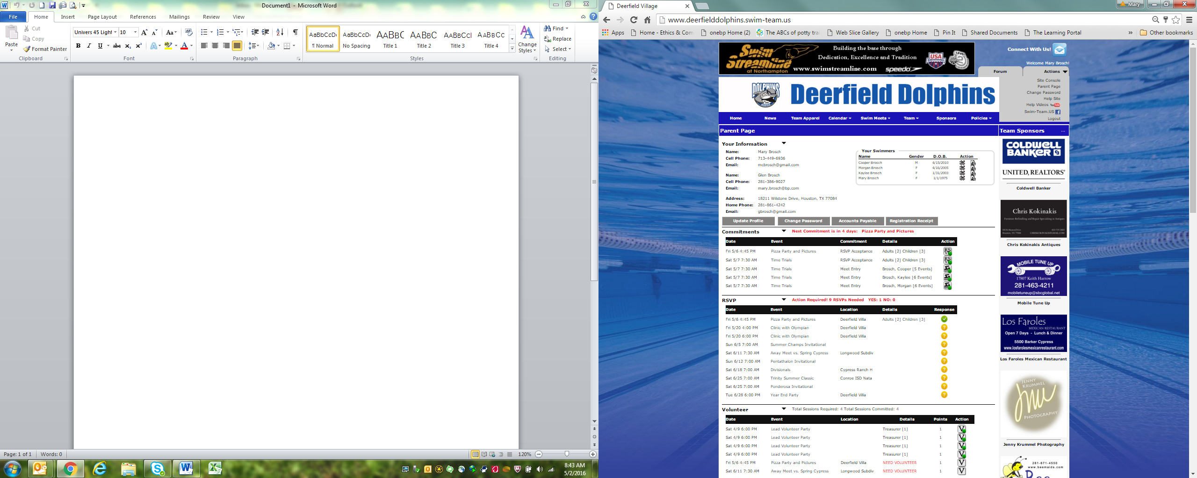
CLICK HERE
CLICK HERE
RSVP and Meet Entry HERE
VOLUNTEER HERE

To RSVP, select Yes and Save.
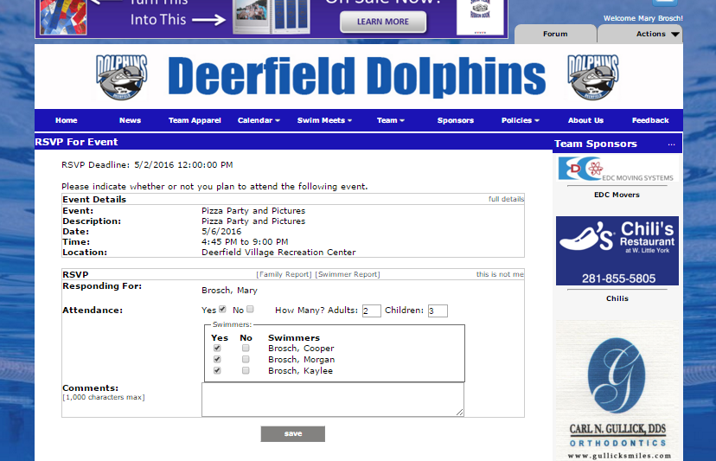

MEET ENTRY
Look for this symbol next to your child’s name.
Find your child’s name in drop down box, then click on Add Entry on the right.
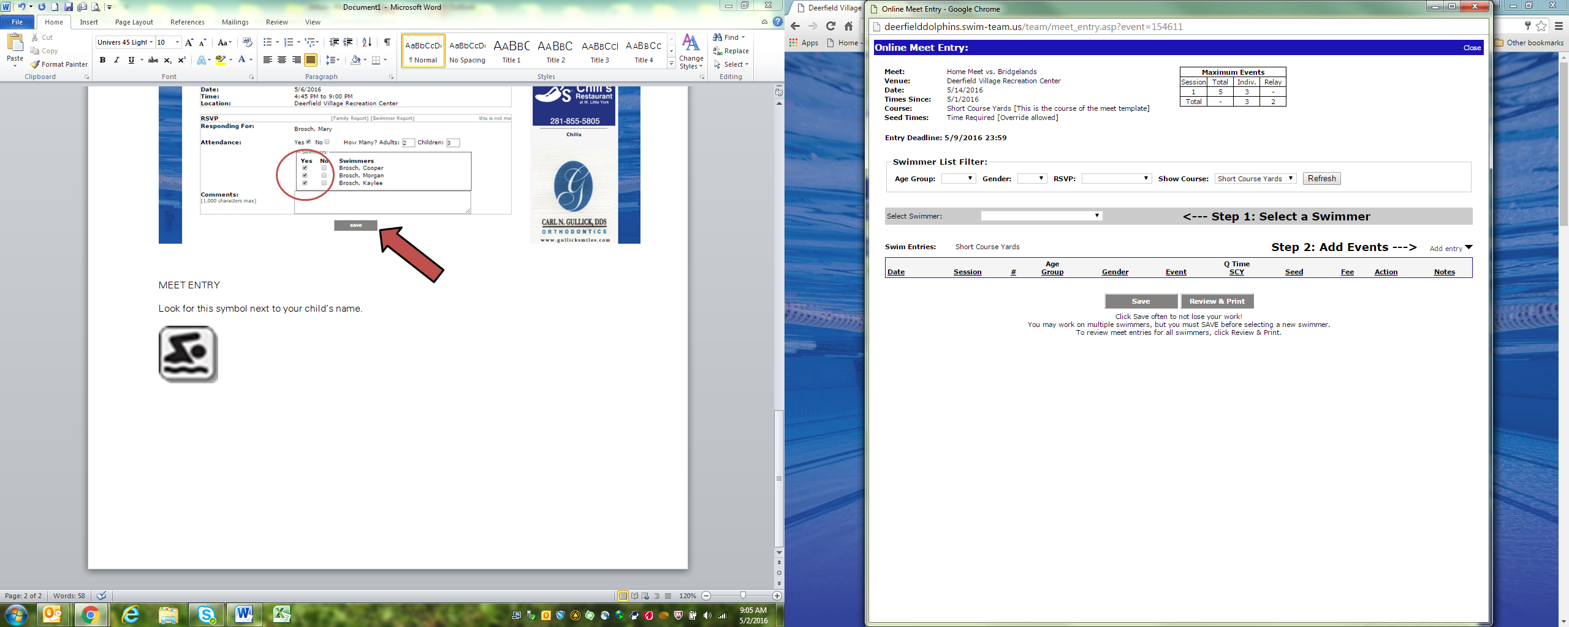

Next, select the events your child will swim. Click SAVE when done.
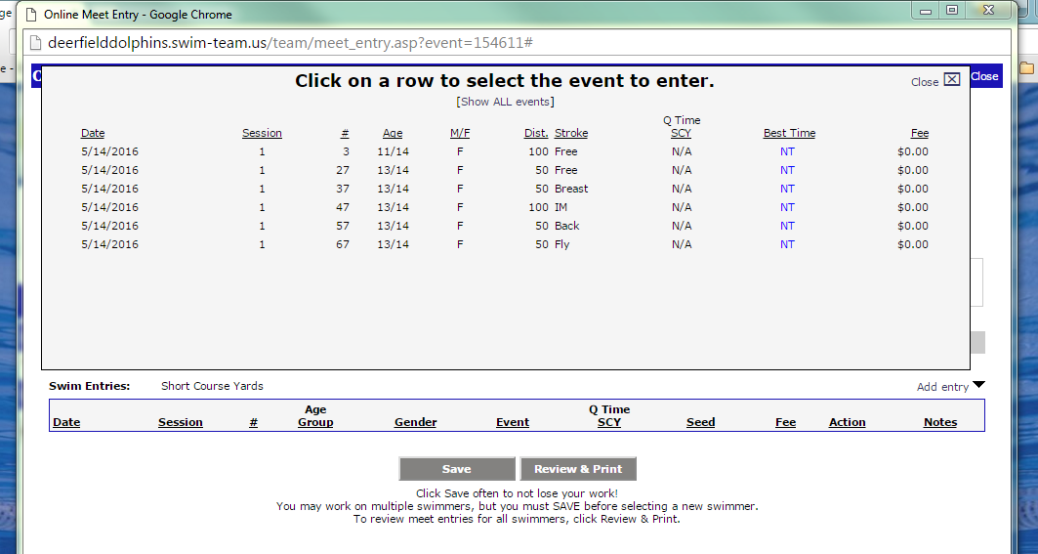

To Volunteer
Look for this symbol next to an event.
This screen will open. Where a volunteer is needed, there will be NEED VOLUNTEER in red. Click on that to sign up by selecting your name from the drop down box.
