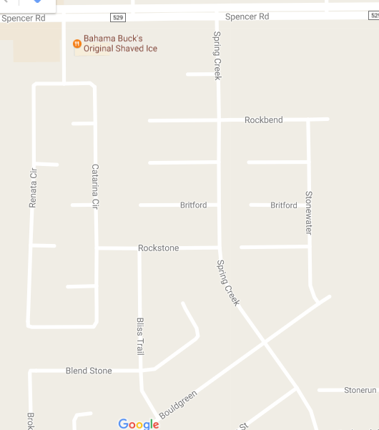
Come in off 529 at Spring Creek at light. Go through the stop sign. (from stop sign to stop sign In front of the pool will be 1 way during the meet) Drop off in front of pool and follow the arrows on the map. You will turn into the church parking lot off 529 to get to parking. The shuttle will be at the entrance on spring creek. There will be guards at pool and at the parking lot to watch cars and direct traffic.
park

