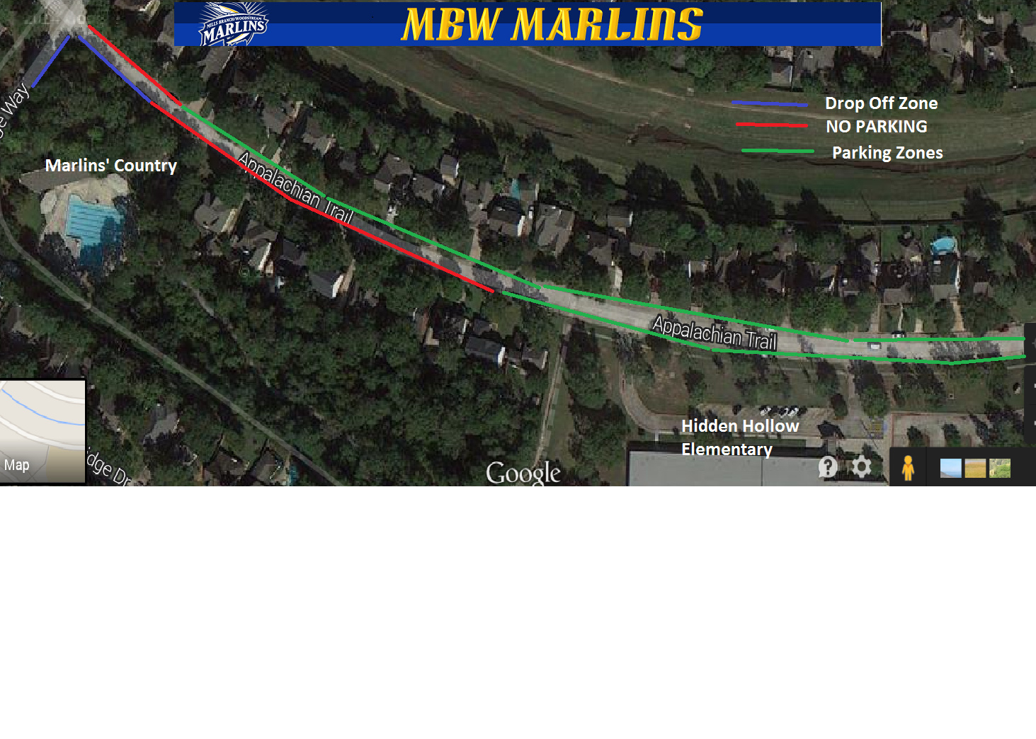

Please adhere to the above parking diagram for the safety of swimmers and the residents of Mills Branch.
The Blue Zone at the intersection of Mill Bridge Way and Appalachian Trail is for the Dropping off of swimmers and equipment.
The RED ZONE is a NO PARKING ZONE – This is to allow for the response of Emergency Vehicles as the roadway in this area is narrow and vehicles parked on both sides hinders Emergency Vehicle Response.
The Green Zone is approved for parking as well as the Parking Lot at Hidden Hollow Elementary.
*POSTED NO PARKING AREAS ARE SUBJECT TO CITATIONS BY THE HOUSTON POLICE DEPARTMENT*
Please remember the following laws as well
An operator may not, except momentarily to pick up or discharge a passenger, stand or park an occupied or unoccupied vehicle:
- NO PARKING within 15 Feet of FIRE HYDRANT
- NO PARKING within 20 Feet of CROSSWALK at INTERSECTION
- NO PARKING within 30 Feet of Stop Sign
- NO PARKING blocking Private or Public Driveways
- NO PARKING where NO PARKING SIGNS are located
Please help us keep the swimmers safe and be good neighbors to the residents of Mills Branch and observe the above rules for parking.
*The Pool Parking Lot is Reserved Parking Only during swim meets.

