Windrose Stingrays Swim Meet Logistics

5740 Pinelakes Blvd. Spring, TX 77379

Setup: Bring tents as there is not a lot of shade around the pool. Visiting team set-up area is on the south/southwest side of the pool. It will be on your left as you walk up to the entrance.
Parking: Parking can be found along the north and south sides of Pinelakes Blvd.
Concessions: Standard Items including Breakfast items (Breakfast Tacos, Pancakes, etc.) and Lunch items (Hamburgers, Sausage on a stick, etc.).
Visiting Team Warm-up: 7:45 – 8:15 AM


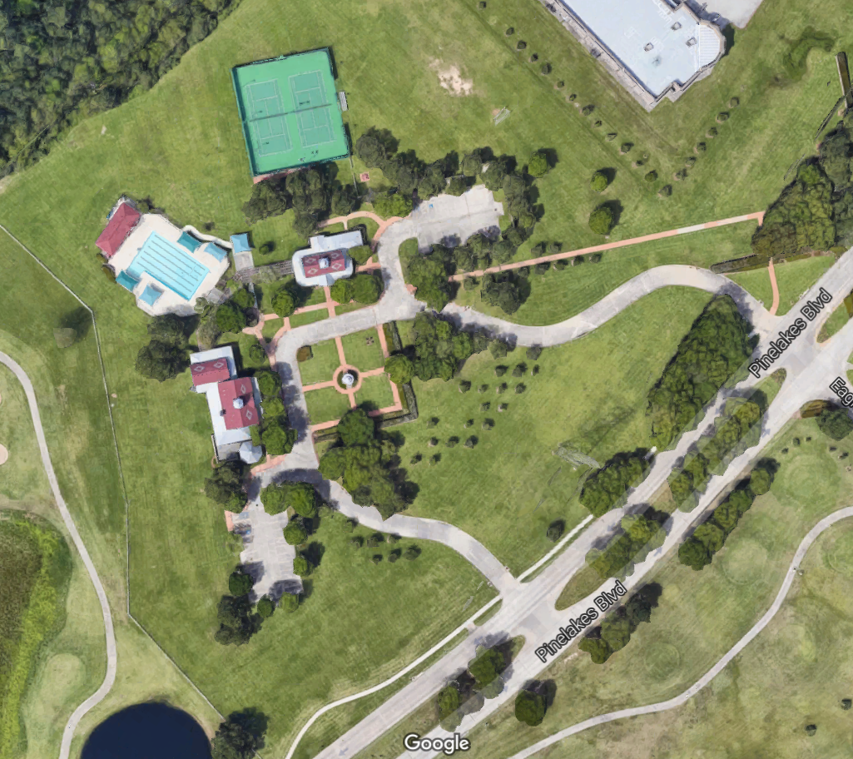
W
E
S
N
PUBLIC PARKING

VISITOR SETUP

DROP OFF

DROP OFF

STINGRAY SETUP

CONCESSIONS

PUBLIC PARKING

PUBLIC PARKING

RESERVED PARKING

RESERVED PARKING

