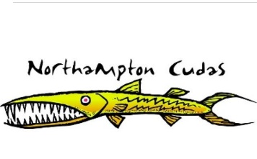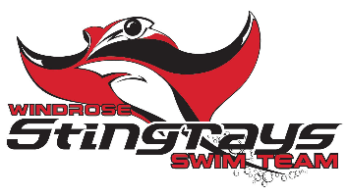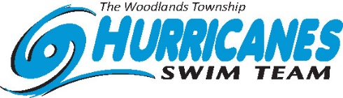
NWAL Division Red 2 T-shirt Order Form
***All Orders Due to Otters Team Representative by June 1***
Parent Name: _________________________ Email: ______________________________
Swim Team: _________________________ Phone: ______________________________
ITEM |  |  | PRICE | QTY |  | TOTAL | DELIVERED
(please indicate number of each size in the blank – Ex. _1__ S)  T-shirt – Gildan Soft Style T-shirt  YOUTH  ______S ______M ______L ______XL  ADULT  _______S ______ M _______ L ______XL ______2XL |  |  | $15
Tank Top – Gildan Unisex Cotton Tank Top  ADULT  _______S ______ M _______ L ______XL ______2XL |  |  | $15
****If the size is not listed we do not have that size****
To see color photos online please go to https://oakridgenorth.swim-team.us/
Click on top left link: Divisional Tshirts
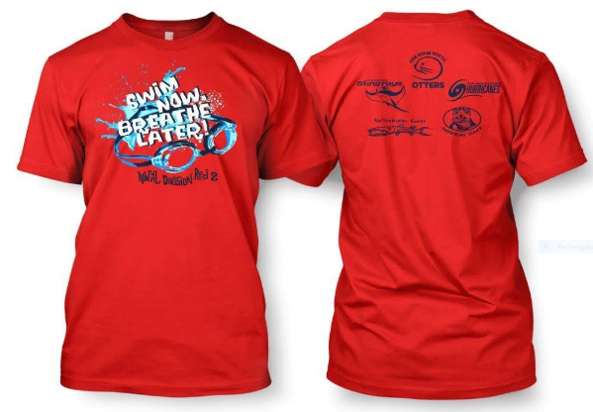
TOTALS:
FOR OFFICE USE ONLY
DATE | CHECK # | CREDIT CARD | CASH |  | INITIALS
For Spirit Wear Questions, please contact Allison.Cloth@gmail.com

