Cudas & Cuda families!
Our first dual meet is this Saturday against The Woodlands Hurricanes. Please make sure you have completed the meet entries on the Cudas website by this evening, Tuesday the 9th, so your swimmer will be able to participate.
We will be the visitors. Their pool address is 5001 South Alden Bridge Drive, The Woodlands, TX 77382. Below is a google map image of the route and approximate travel time.
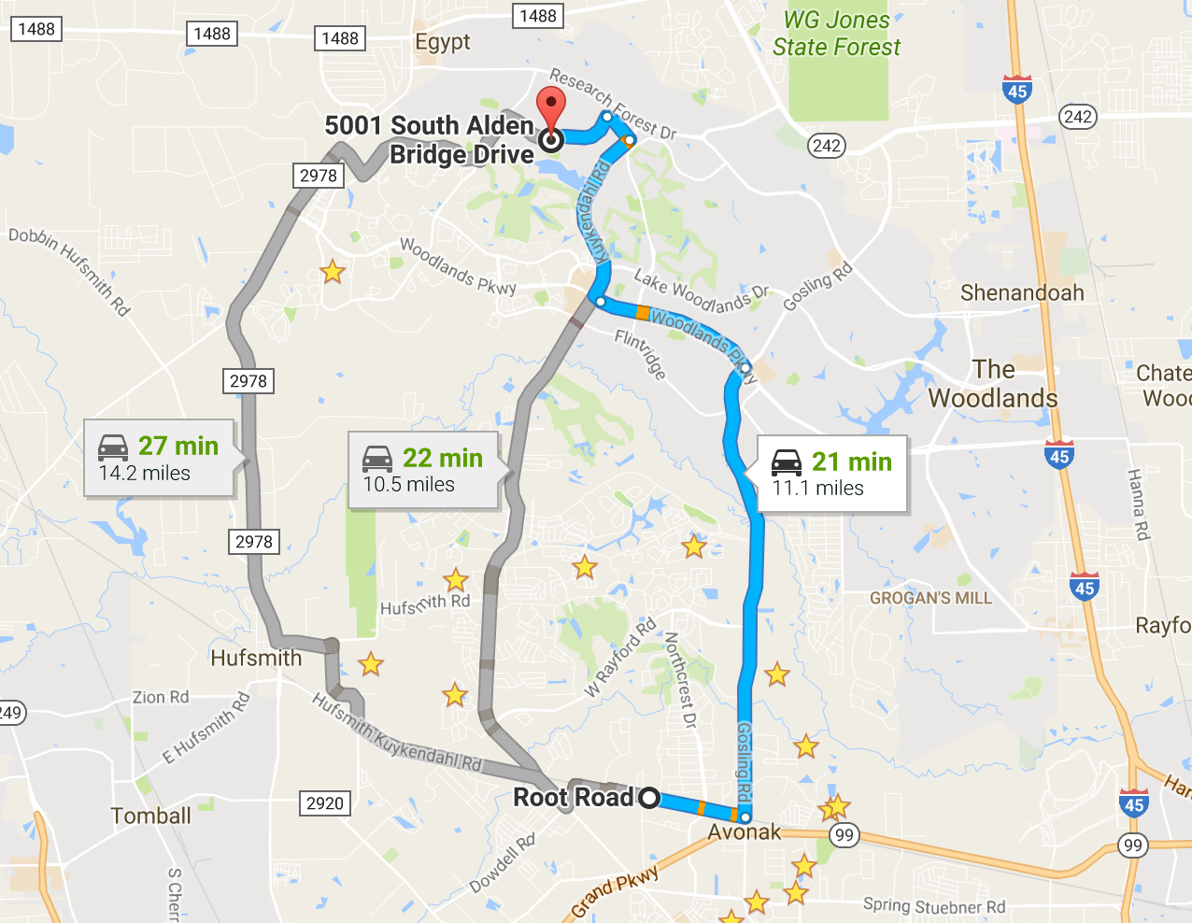
They have a 6 lane, 25 yard pool. Our set up is in the parking lot next to the pool. See attached image of the pool and visiting set up.
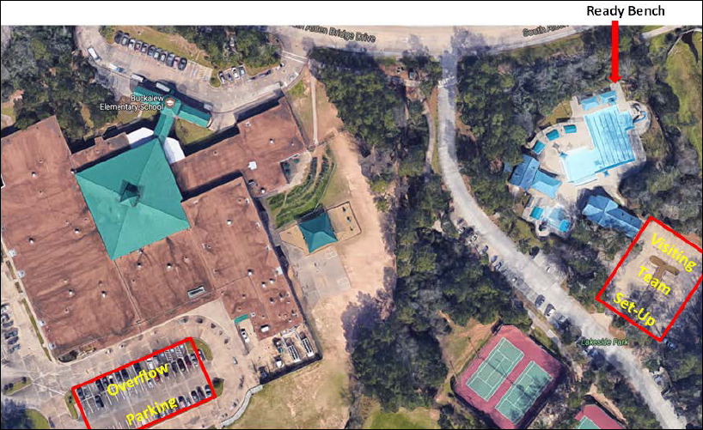

Check-in:
There will be a check-in table in the parking lot where the Cudas set up. Check-in opens at 6:45am and closes at 7:30am. Please check-in at the table so that you can participate in the meet.
Warm ups:
Hurricanes 7:00-7:30AM
Cudas 7:45-8:15AM
Meet starts 8:30AM
Heat Sheets:
Heat sheets will be available for purchase-cash only.
Concessions:
Food & beverage for both breakfast and lunch will be available on the pool deck by Chick-fil-A (cash only). We will also have Orange Leaf yogurt for sale (cash only).
Visiting Team Setup Area:
Set up for our team will be on the right side of the Lakeside pool building in the parking lot (on map above). The Hurricanes will open the gate for easy access to pool and ready bench. The Lakeside building has bathrooms on the outside next to team area, as well as, on the inside of building. Please keep the handicapped parking spaces empty for use if needed.
Parking:
There is parking in the parking lot, along Alden Bridge Dr. as well as next door in Buckalew Elementary parking lot (on map above). Please just do not park in neighborhoods.
We request that whenever possible please carpool.
Please obey these basic parking rules:
• No parking at a stop sign.
• Do not block a fire hydrant or driveway.
• No parking in residential neighborhoods.
• Do not park where "No Parking" signs are posted!
Volunteering:
If you have signed up to volunteer in the following areas: timing/scribe, ready bench, computers or ribbon writing, please check in with Angela Collins. If you signed up to officiate, please check in with Walter Baskett. Most of these areas have a meeting before the meet begins to discuss responsibilities and shift times.
New Swimmer Information:
If this is your first meet, most families bring pop-up tents (or share one with other families), portable chairs and ice chest with snacks and waters. The swimmers usually stay in their age group tent and have a tent parent that will help them get to their events. Don't forget sunscreen, Cudas swimsuit, cap and goggles. Also, have the swimmer wear their Cudas shirt.
We look foward to a fun and fast meet! Go Cudas!
Gary Cooper
Team Representative

