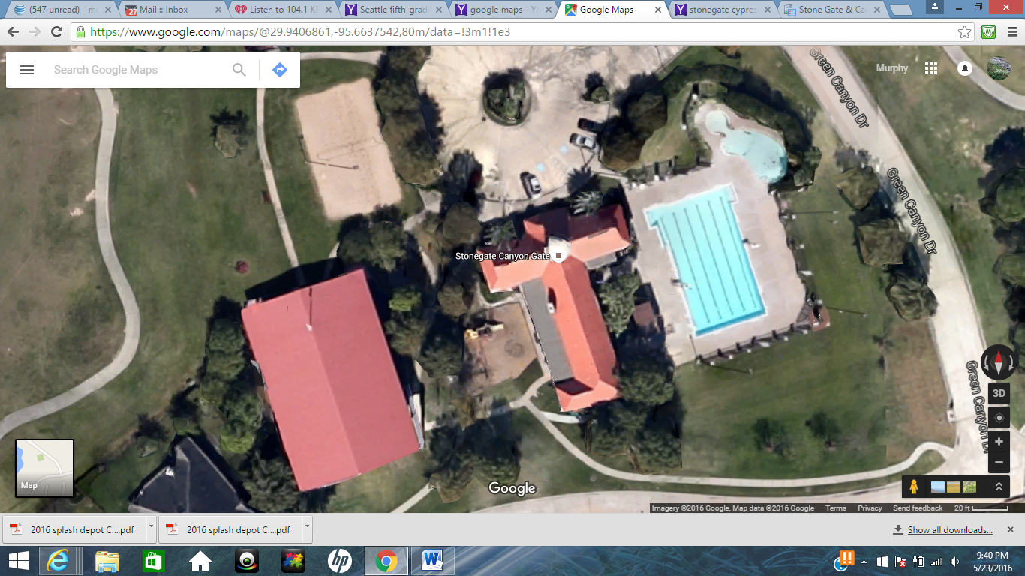
Golf Course – Please Stay Off
Visitor Set-Up Area
Parking on grass – Please follow parking attendants instructions
Gator Set-Up
Covered Basketball Court
Visitor Half

To get to the pool, all vehicles will go to a guard gate. Just tell them you are there for the swim meet.
Parking is allowed on one side of Green Canyon Drive and the green are across from Red Crest Drive. All vehicles must be backed in. Please follow parking attendants’ instructions.
We split the covered basketball court in half to share with the visiting team.

