Instructions on how to Volunteer
Please visit: www.pfw.swim-team.us
Click on the “Calendar”
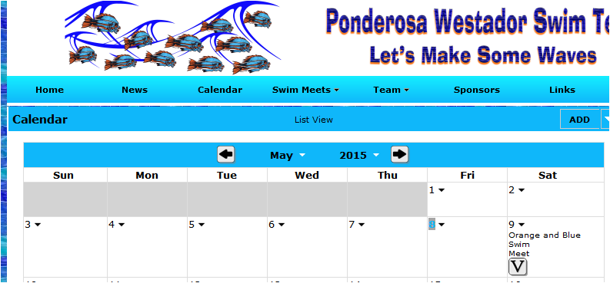
You will see a “V” icon (click)
Another page will come up (See below-example)
Please fill in your name for the position and shift you’d like to do. Then hit “SAVE”. Sign-up is on a first come first serve basis.
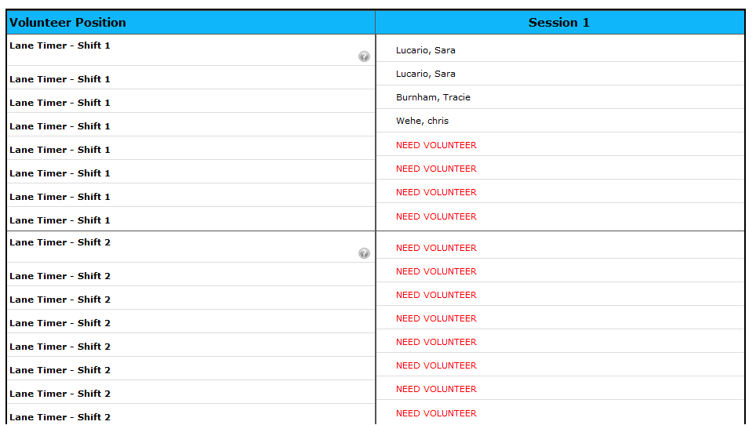
This completes your volunteer sign-up for the most recent meet date! Please note:
Amanda Westfall is our Board Volunteer Coordinator, she may approach you regarding validation of your assignment or request, your cooperation & help is greatly appreciated!

