Visiting Team Information

Visitors Tents:

Tent set up for visitors is on the back side of the pool house and may not be set up in the kiddie pool area inside the fence. Tent set up is not allowed the night before. Home team sets up in the parking lot and just southwest of the pool. Area two is where a volleyball court used to be. Large sandy area, I would highly recommend a tarp under your canopy if you utilize this area. The acoustics for announcements are less audible in area 2.
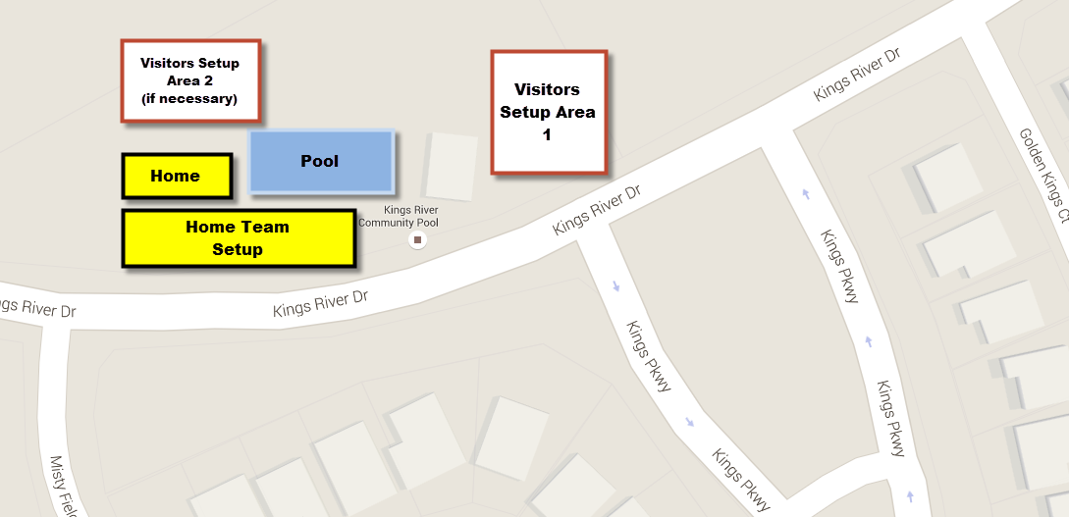
Drop Off Zone:

There will be Drop Off/Pick-up zones located on Kings River Dr. directly in front of the pool:

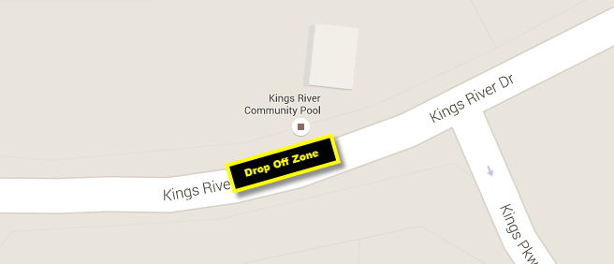

Parking:
Parking is recommended up and down Kings River Dr. There are a couple of residential areas that are cul-de-sac near the pool. We ask our home and visiting parents to not park in these side streets as it severely restricts ingress/egress to these residential areas.

