Driving Directions
Timberlane Pool: 2810 Wood River Rd, Spring, Texas 77373
to
Holiday Inn: 120 Southpoint Dr, Livingston, Texas 77351
Staring at Timber Lane Pool, tun RIGHT on to Woodriver (main drive). At the light turn RIGHT onto Aldine Westfield. Continue on Aldine Westfield until you reach FM 1960. Turn LEFT onto FM 1960. Continue on FM 1960 until you reach US-59. Turn LEFT onto the feeder road of US-59 (going over 59 on 1960). Take the first on ramp to US-59 North. Continue on US-59 North for about 50 miles and take EXIT FM 1988 S. Turn RIGHT onto Southpoint Dr, arriving at your destination, Holiday Inn. (BLUE ROUTE on map indicates directions above)
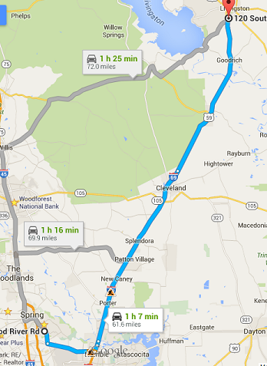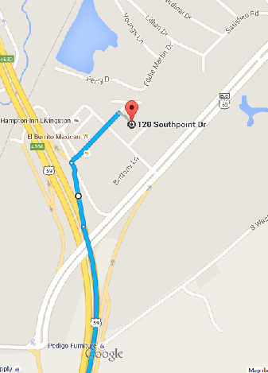
These directions are straight from Google maps. If they are incorrect blame Google, not me.

Driving Directions
Timberlane Pool: 2810 Wood River Rd, Spring, Texas 77373
to
Livingston Pool: 709 W. Matthews St, Livingston, Texas 77351
Staring at Timber Lane Pool, turn RIGHT on to Wood River (main drive). At the light turn RIGHT onto Aldine Westfield. Continue on Aldine Westfield until you reach FM 1960. Turn LEFT onto FM 1960. Continue on FM 1960 until you reach US-59. Turn LEFT onto the feeder road of US-59 (going over 59 on 1960). Take the first on ramp to US-59 North. Continue on US-59 North for about 50 miles and take EXIT US-59 BUS/Pan American Dr toward Livingston Woodville. Continue on US-59 BUS N. for approximately 1.7 miles until you arrive at W. Matthews St. Turn LEFT onto W. Matthews St. Continue on W. Matthews St. until you see the pool on the, find a place to park.
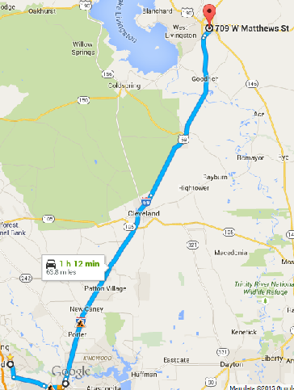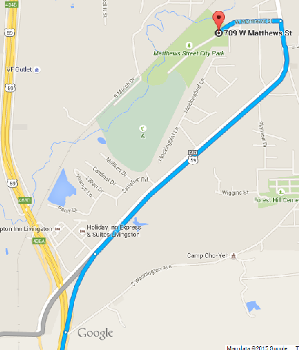
These directions are straight from Google maps. If they are incorrect blame Google, not me.

Driving Directions
Holiday Inn: 120 Southpoint Dr, Livingston, Texas 77351
to
Livingston Pool: 709 W. Matthews St, Livingston, Texas 77351
Head SOUTH on Southpoint Dr, turn LEFT on Commerce St. Continue on Commerce St until you get to Pan American Dr. Turn LEFT onto Pan American Dr. Continue on this road until you get to W. Matthews St. Turn LEFT onto W. Matthews St. Continue on W. Matthew St. until you reach the pool.
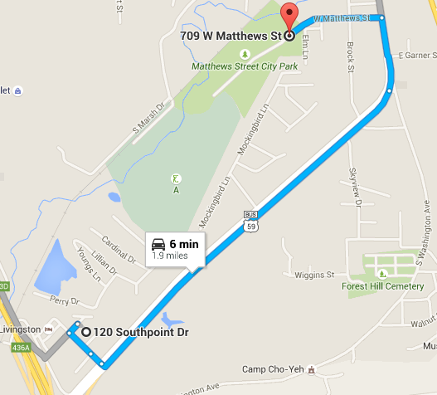
These directions are straight from Google maps. If they are incorrect blame Google, not me.

