2014 Divisional
Water Bottle Order Form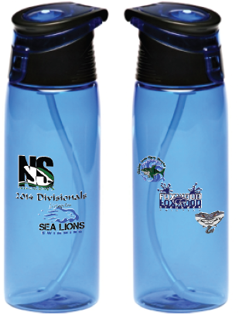
Presale Amount $12.00 (6/9/2014 is the last day for Presale Orders)
Day of Divisionals 6/21/2014 $15.00
Name: Order Date:
Swim Team:
Phone Number: Email:
Qty Requested: Total Amount:
This Section to be filled out by a Foxwood Swim Team Board Member.
Please make checks Payable to your Swim Team!
Cash: Check: Receipt #:

