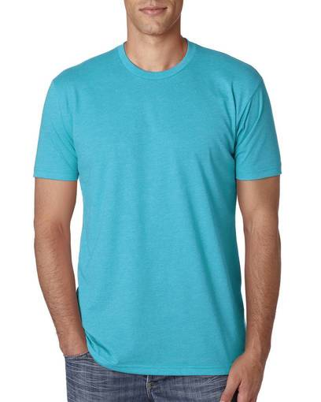

1) next Level brand unisex tee. Color is as pictured. Georgetown logo on front nothing on back sizes XS- 3XL

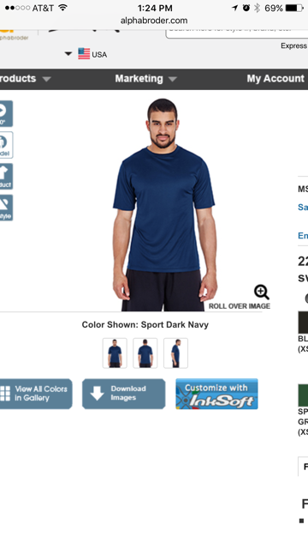
2) unisex Performance Tee in Navy. Size small through 3XL

Bella women's tee in royal marble. Size xs- xl

