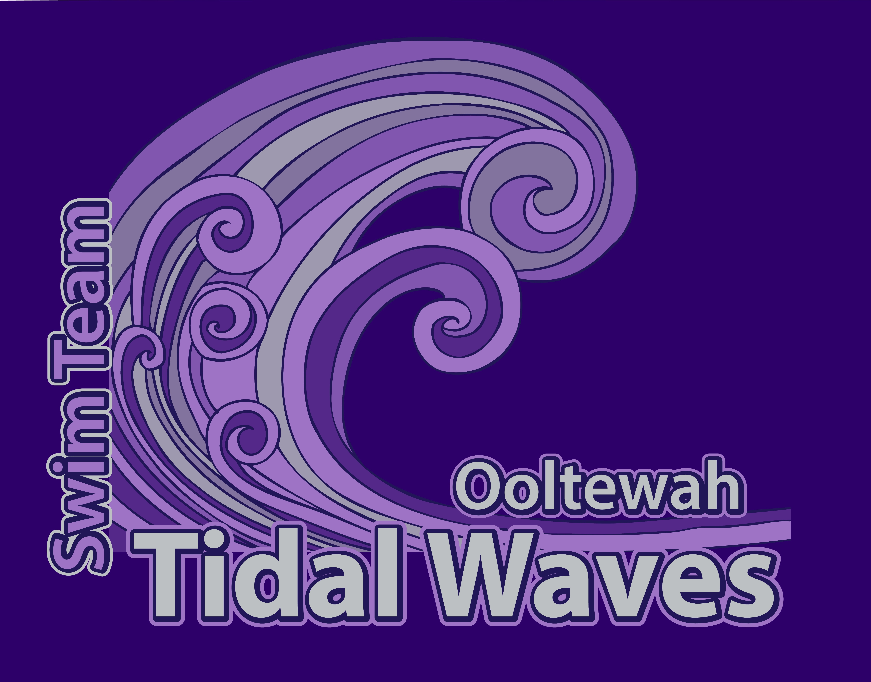

Ooltewah Tidal Waves Swim Association
2017 Sponsorship Form

Business Name
Authorized Person
Business Mailing Address

Business Phone
Email Address
Website:
New Sponsorship fee of $300 (renewal fee is $250) includes:
- Your logo on the back of our team t-shirts
- Your logo featured on our team website, with a link to your website
- Your business on a full-color vinyl banner displayed at home meets
- Your business mentioned during announcements between events at our home swim meets
- Your logo featured on our meet programs
Requirements: Email finished artwork, in PDF format, to Kelley Weathers at kweathers75@hotmail.com Color artwork can be used for our website, but t-shirt and meet program logos will be single-color.
Payment Received Date
Team Representative
We greatly appreciate your generous donation and thank you for being a proud supporter of our team and the youth in our community.
Contact Kelley Weathers for form/payment pickup at 423-667-2612 or kweathers75@hotmail.com or mail to
P.O. Box 428; Ooltewah, TN 37363

