City Meet Survival Guide for Parents
City Meet Friday—11 and older swimmers
City Meet Saturday—10 and under swimmers
City Meet Sunday—Swimmers who finish in the top 16 places in their event for their age group
*Please be prepared to swim on Sunday as you may be in a relay or individual event that makes it back!
Location and Parking: City Meet is at Allen Jones Pool on the UT Campus. (2200 Andy Holt Avenue). Parking is free and located at the Metron/Kingston Building next to Tyson Park (2309 Kingston Pike.) It is approximately one mile from the AJIAC. Shuttle busses will be provided between the pool and parking area from 7:00 a.m. until the end of the meet on all three days. A $2 per swimmer shuttle fee will be added to the entry fee for each swimmer and has already been paid by GMST. The swimmer and their family will have unlimited use of the shuttle service throughout the weekend. There will be a designated shuttle bus stop on UT Drive between the Student Aquatic Center and the Allan Jones Intercollegiate Aquatic Center. Traffic on UT Drive will be one-way throughout the meet, from Andy Holt Avenue to Volunteer Blvd.
Our tent: At City meet, each team is assigned a tent location around the outside of the pool building. We will send out the location of our tent as soon as we receive it from GKAISA,

Under the tent and what to bring: As this is a long day for everyone, please make sure you pack accordingly. Some suggested items:
- Plenty of water, Gatorade, and healthy snacks (fruit, jello, granola bars, protein bars, bagels)- concessions will be available inside the pool, but a cooler is suggested
- Extra towels
- A chair to sit in for your swimmer and for yourself or a blanket to sit on
- Games and entertainment- you may have a long time between your swimmers events. Many people bring card games, Nintendo DS, Ipod or other music source, board games, markers and paper, books to read, etc.
- Sunscreen- although we will have a tent and most areas are tented or shady, you never know!
- Extra goggles, cap and suit- There will be goggles and caps and other supplies for sale inside the aquatic center as people will set up shops. For those of you who have been before, it can be a long walk and crowded. Bring extras just in case as you won't have time if you're in a pinch!
- Highlighter and sharpie- to find your events in the heat sheet and write them down!
- Fan and mister- It is HOT outside!

Meet Timeline:
7:00 am- the building opens for workers and swimmers.
7:45 to 7:50am- GMST Swimmers should be at the tent and ready to stretch and warm-up.
8:10-8:30- GMST warm-up. Please be under the tent by 7:50 to get settled. The coaches will be checking in swimmers and doing stretches and cheers, and we will walk into the building before our warm up time. We only have exactly 20 minutes, and sometimes less, in the pool so be ready to walk into the pool as a group (around 8:00) and get in the water.
9:00- Meet begins. The meet will last until around 4:00 (sometimes much earlier).
How the Meet Works- Finding your events: City Meet is the championship meet for all the teams within the Greater Knoxville Area league. There are approximately 30 teams and will be a lot of swimmers entered in the meet. Some events can have upwards of 200 swimmers entered in the event. Swimmers are placed in the meet based on their entry time that was submitted by the coaches. Therefore, they should be swimming with other swimmers around their skill level and speed. This makes a fun, competitive day, but requires a lot of organization.
When you arrive at the pool, find a "heat sheet". You can purchase one for the day at the front of the pool building, or you can share with other parents under the tent. The heat sheet will be like a road map for the meet and how it progresses. If you've never used one, ask a parent under the tent to help you (or see below for an overview).
The meet is laid out much like a normal dual meet, just on a larger scale. There are also 2 additional events that your child could be swimming- the Mixed or Co-ed Relay (2 girls and 2 boys from the same age group) and the 50/100 freestyle. The heat sheet is laid out in the order of the meet. Beginning with the Co-ed Relay and ending with the free relay. The order of events at City Meet is as follows:

Events 1-10: Co-Ed Relay
Events 11-20: Individual Medley (IM)
Events 21-30: 25/50 freestyle
Events 31-40: Medley Relay
Events 41-50: Backstroke
Events 51-60: Breaststroke
Events 61-70: 50/100 Freestyle
Events 71-80: Butterfly
Events 81-90: Free Relay

Within the event, the heat sheet will show each individual swimmer's name and the heat and lane they will be swimming in. It will look similar to this: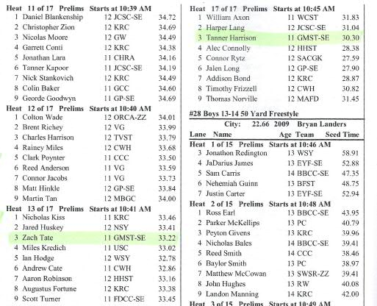
A highlighter will be your best friend! You will need to go through the heat sheet and find all of your child's races. Notice that it has a "start time" as calculated by the system, but do not rely on this time as the meet can run ahead or behind and is hardly ever on time.
Relays will be posted on the bulletin boards under the tent. Pay attention to the lettering of the relay your child is on- GMST A, GMST B, etc. Relays will look similar to this in the heat sheet:
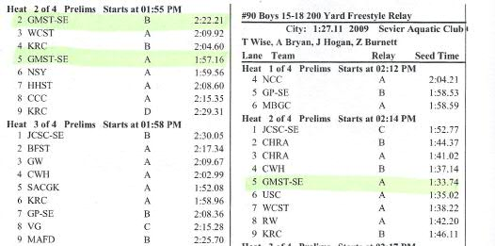
Make sure you select the correct relay- Some events may have up to GMST D or E.
How the Meet Works- Getting your swimmer to their races: The meet will utilize the clerk of course to get swimmers ready for their swims. The announcer will make a call for all swimmers in a particular event over the intercom system. The call will be made a few races prior to their race due to the number of swimmers being organized. Please be listening for the calls. Also note that the boys and girls swim on separate sides of the pool so often the boys become much further ahead than the girls are. You have to listen closely to the announcer or check with the clerk of course tents on who is being called.
When the announcer calls for the event they are swimming, YOU are responsible for taking your child to the clerk of course tent. They will sit under the clerk of course tent and wait until their name is called. Sometimes, the wait under the clerk of course tent can take a while or the announcer may call events too early. Please be aware of this when taking your child to the tent. You may want to take water for them to drink while they are under the tent and also make sure they use the bathroom before sitting under the tent. They will not have an opportunity to do any of this after they are seated.
When their name is called, a parent volunteer will hand them their "card" and seat them in a chair in the order that they are swimming. From there, your child will be escorted by parents and moved into position to swim.
**If your child does not show up under the clerk of course tent, they will not be allowed to swim** This is very important for those older swimmers who lose track of time or just don't feel like going over there- They will not let you swim if you are not seated with the rest of your heat when they walk into the building!
Once you are comfortable that your child is seated and handed over to the parent volunteers working in the clerk of course, you may leave and go find a seat to watch the swim from the upper portion of the pool with bleachers. Parents do not have access to the pool deck level, unless they are working in a volunteer position. The coaches will be on both sides of the pool watching your child's swims and will be available in case they need anything.
After your child finishes their race, they can come speak to the coaches, who will be on deck at both sides of the pool, and then they will exit the building through a door on the side of the building. The coaches will walk the children through which way they will need to exit during the warm-up time. Please meet your child there or under the tent. The door they exit out of is very close to the tent.
After the swim- checking results: After the event is over, the results will then be posted in the lobby of the pool building. All swimmers that finish in the TOP 16 of their event are invited back to swim on Sunday. The results will also list the 2 alternates (17th and 18th) that will be able to swim if someone does not show up. Sunday is the day when all the points are scored and it is a big honor to swim on this day. If your child makes it back in either a relay or an individual event, please plan to be at the pool ready to swim on Sunday. Our warm-up time will be at 7:40-7:55 on Sunday. Please be at the tent by 7:30 ready to swim. Finals day is very fun as the pool configuration is different and swimmers names are announced over the intercom. Swimmers that finish in the top 16 in an event receive a ribbon or a medal.
Tracking the meet through the radio: Parents and swimmers can bring battery powered radios to the meet for use under the tent. GKAISA broadcasts what event is in the pool and what event is being called at the clerk of course over an AM radio station. They will also use twitter to let people know what event is in the pool. They will not have speakers set up outdoors so plan on bringing a radio or using your phones.

Remember: Every swim counts!
Do not get discouraged by where your child is placed on the heat sheet or what relay they are put on. Every swimmer has a chance at coming back on Sunday and every swimmer has the chance of improving their time!
This meet is their opportunity to show you their accomplishments from the summer and we are so proud of every swimmer that swims in it!

