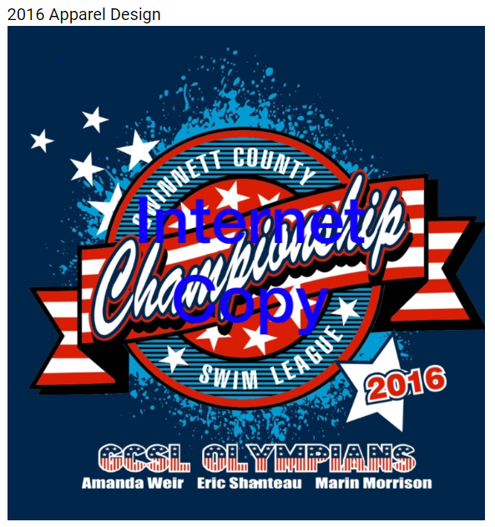

What’s available to this year? Tie dye t-shirts, Hooded Sweatshirts (“Hoodies”) and Pigment dyed tanks.
COLORS:
The T-Shirts will be Royal Tie Dye. $18 ($19 XXL)
The Hoodies will be Sapphire blue. $23 ($25 XXL)
The Tanks will be Carolina Blue. $19 ($20 XXL)
Checks MUST be written to Edinburgh Marlins and placed in McCarthy Family File (Kendall & Kadyn) WITH items/sizes, by Friday 6/24 MMM. Late orders cannot be placed and will need to be purchased at the County Meet, if available.
Questions – Text Kim at 678-485-3572

 | Youth S | Youth M | Youth LG | Youth XL | Adult S | Adult M | Adult LG | Adult XL | Adult XXL | Total Quantity | Price | TOTAL
T- Shirts |  |  |  |  |  |  |  |  | +$1 |  | X $18
Hoodies |  |  |  |  |  |  |  |  | +$2 |  | X $23
Tanks |  |  |  |  |  |  |  |  | +$1 |  | X $19
 |  |  |  |  |  |  |  |  |  | GRAND TOTAL

